CSS ISLAMIC STUDIES · T8QA
بِسۡمِ ٱللَّهِ ٱلرَّحۡمَٰنِ ٱلرَّحِيمِ
Topic VIII — Public Administration and Governance in Islam
The Question Answers · Every past-paper question of Topic 8, 2016–2026, answered as a model
Nine model answers — public administration and civil servants, the Islamic political system under the Khilafat, the election of the Caliphs and democracy, the responsibilities of civil servants, reforming Pakistani politics, Hazrat Ali's bravery and juridical wisdom, and accountability in three shapes: of rulers, in Pakistan, and under the Rashidun. Each begins with an answer map that states exactly what the question asks.
Edition of September 2026 · covers the papers of 2015–2026 · written for CSS 2027 and after
Contents
HOW TO BUILD THE CONTENTS
The Contents below is left empty on purpose. In Microsoft Word, right-click anywhere on the grey line below and choose Update Field → Update entire table → OK. The full table of contents with page numbers will appear.
On a Mac: right-click (or Control-click) the line → Update Field. If you edit the notes later, repeat this step to refresh the page numbers. You can also press Ctrl + A then F9 (Windows) to update every field in the document at once.

How to Use These Answers 5
What is in this document 5
How every answer is built 5
Answer 1 · The Concept of Public Administration in Islam and the Responsibilities of Civil Servants (CSS 2016) 6
Decoding the question 6
The model answer 7
(1) Introduction 7
(2) The concept of public administration in Islam 7
(3) The responsibilities of civil servants 9
(4) The lesson for Pakistan 11
(5) Conclusion 12
Why this answer scores 12
Answer 2 · The Salient Features of the Islamic Political System under the Pious Khilafat (CSS 2016) 13
Decoding the question 13
The model answer 13
(1) Introduction 13
(2) The salient features 14
(3) Relevance for Pakistan 17
(4) Conclusion 17
Why this answer scores 17
Answer 3 · The Election of the Rightly-Guided Caliphs and How Far Their System Was Democratic (CSS 2017) 18
Decoding the question 18
The model answer 18
(1) Introduction 18
(2) How the Caliphs were elected 19
(3) To what extent was the system democratic? 20
(4) The lesson for today 21
(5) Conclusion 22
Why this answer scores 22
Answer 4 · The Responsibilities of Civil Servants in the Light of Islamic Teachings (CSS 2018) 23
Decoding the question 23
The model answer 23
(1) Introduction 23
(2) Responsibilities towards Allah 24
(3) Responsibilities towards the state 25
(4) Responsibilities towards the public 26
(5) Responsibilities towards himself and his work 27
(6) The models — Umar and Ali (RA) 28
(7) Pakistan — the problem and the cure 28
(8) Conclusion 29
Why this answer scores 29
Answer 5 · Reforming Pakistani Politics in the Light of the Islamic Political System (CSS 2019) 30
Decoding the question 30
The model answer 31
(1) Introduction 31
(2) The aspects of the political system of Islam 31
(3) The problems of Pakistani politics 31
(4) Suggestions for reform 32
(5) Conclusion 35
Why this answer scores 35
Answer 6 · The Bravery and Juridical Wisdom of Hazrat Ali (RA) (CSS 2020) 36
Decoding the question 36
The model answer 36
(1) Introduction 36
(2) The bravery of Hazrat Ali (RA) 37
(3) The juridical wisdom of Hazrat Ali (RA) 38
(4) Conclusion 39
Why this answer scores 39
Answer 7 · The Principles of Accountability of Rulers in the Quran and Sunnah (CSS 2021) 40
Decoding the question 40
The model answer 40
(1) Introduction 40
(2) The principles of accountability of rulers 41
(3) The principles in practice — the Rashidun 45
(4) Conclusion 46
Why this answer scores 46
Answer 8 · Idealising Pakistan's Accountability System in the Teachings of the Holy Prophet ﷺ (CSS 2024) 47
Decoding the question 47
The model answer 48
(1) Introduction 48
(2) Pakistan's system of accountability 48
(3) Its weaknesses 49
(4) Idealising the system in the teachings of the Holy Prophet ﷺ 49
(5) The ideal at a glance 51
(6) Conclusion 52
Why this answer scores 52
Answer 9 · The Concept of Accountability and the Highest Standard of the Rashidun Caliphs (CSS 2026) 53
Decoding the question 53
The model answer 54
(1) The concept of accountability in the Islamic system 54
(2) The Rashidun Caliphs — examples of the highest standard 55
(3) Why the Rashidun set the highest standard 56
(4) The lesson for today 56
(5) Conclusion 57
Why this answer scores 57

How to Use These Answers

What is in this document
# | Paper | Question (short) | Answer
1 | 2016 Q6 | The concept of public administration in Islam; the responsibilities of civil servants | Answer 1
2 | 2016 Q7 | Salient features of the Islamic political system in the light of the pious Khilafat | Answer 2
3 | 2017 Q4 | How were the Rightly-Guided Caliphs elected? Was their system democratic? | Answer 3
4 | 2018 Q5 | The responsibilities of civil servants in the light of Islamic teachings | Answer 4
5 | 2019 Q8 | Suggestions to reform Pakistani politics in the light of the Islamic political system | Answer 5
6 | 2020 Q3 | The bravery and juridical wisdom of Hazrat Ali (RA) | Answer 6
7 | 2021 Q6 | Principles of the accountability of rulers in the Quran and Sunnah | Answer 7
8 | 2024 Q6 | Idealising Pakistan's accountability system in the teachings of the Holy Prophet ﷺ | Answer 8
9 | 2026 Q6 | The concept of accountability; the Rashidun set the highest standard | Answer 9

The two civil-servant questions (2016, 2018) and the three accountability questions (2021, 2024, 2026) each get a different shape:
- 2016: the concept of administration, then the duties.
- 2018: duties grouped by relationship (to Allah, the state, the public, himself).
- 2021: principles.
- 2024: Pakistan's system measured against the Prophet's ﷺ teachings.
- 2026: the concept, then the four Caliphs' examples.

How every answer is built
1. The question, exactly as set.
2. The answer map — the centre states exactly what the question asks; every box is a heading, and every point is a complete idea.
3. Decoding the question.
4. The model answer — headings from the question's words; evidence Quran → Hadith → the Rightly-Guided Caliphs and jurists → law and data; figures; Pakistan; a conclusion with a verse or hadith.
5. Why this answer scores.
TRAP · PRACTICES, NOT PARTIES
When you apply these answers to Pakistan, criticise practices — nepotism, selective accountability, dynastic politics — never a named party or person. The examiner rewards balance.

Answer 1 · The Concept of Public Administration in Islam and the Responsibilities of Civil Servants (CSS 2016)
THE QUESTION · CSS 2016 · Q6 · 20 marks
Highlight the concept of Public Administration in Islam. Explain the responsibilities of Civil Servants.

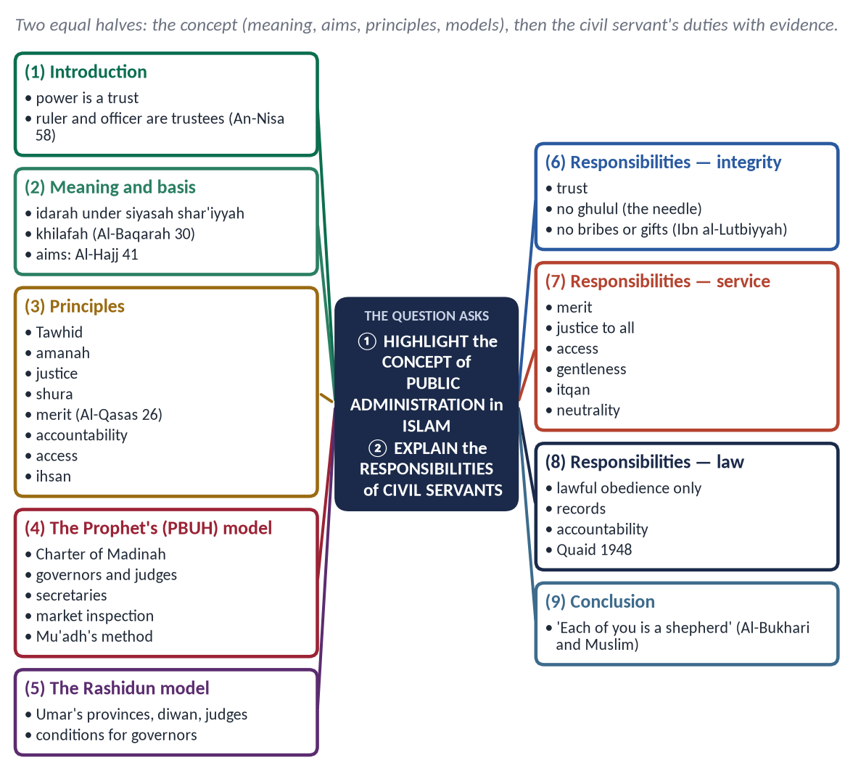
Figure 1 · The answer map: every branch is one numbered heading of the model answer below.

Decoding the question
- 'Highlight the concept' — what public administration means in Islam, its basis, aims and principles, shown through the Prophet ﷺ and the Caliphs.
- 'Explain the responsibilities of civil servants' — the duties of the officer, each explained with evidence. Both halves carry equal marks.

The model answer

(1) Introduction
In Islam, power is not a privilege; it is an amanah (trust). The ruler and every official hold it on behalf of Allah and the people, and must answer for it.
✦ QURAN
﴿إِنَّ ٱللَّهَ يَأۡمُرُكُمۡ أَن تُؤَدُّواْ ٱلۡأَمَٰنَٰتِ إِلَىٰٓ أَهۡلِهَا وَإِذَا حَكَمۡتُم بَيۡنَ ٱلنَّاسِ أَن تَحۡكُمُواْ بِٱلۡعَدۡلِۚ …﴾
“Indeed, Allah commands you to render trusts to those entitled to them, and when you judge between people, to judge with justice.” (An-Nisa, Quran)
➜ Allah commands you to render trusts to those entitled to them, and when you judge between people, to judge with justice.

(2) The concept of public administration in Islam

(i) Meaning
Public administration — idarah (إِدَارَة) under siyasah shar'iyyah (سِيَاسَة شَرْعِيَّة) — is the management of the state's people and resources to deliver justice, security and welfare, as a trust, within the Shari'ah.

(ii) The basis — khilafah
✦ QURAN
﴿… إِنِّي جَاعِلٞ فِي ٱلۡأَرۡضِ خَلِيفَةٗۖ …﴾
“Indeed, I will make upon the earth a vicegerent (khalifah).” (Al-Baqarah, Quran)
➜ 'I am placing on the earth a khalifah.'

(iii) The aims
✦ QURAN
﴿ٱلَّذِينَ إِن مَّكَّنَّـٰهُمۡ فِي ٱلۡأَرۡضِ أَقَامُواْ ٱلصَّلَوٰةَ وَءَاتَوُاْ ٱلزَّكَوٰةَ وَأَمَرُواْ بِٱلۡمَعۡرُوفِ وَنَهَوۡاْ عَنِ ٱلۡمُنكَرِۗ وَلِلَّهِ عَٰقِبَةُ ٱلۡأُمُورِ﴾
“[And they are] those who, if We give them authority in the land, establish prayer and give zakah and enjoin what is right and forbid what is wrong. And to Allah belongs the outcome of [all] matters.” (Al-Hajj, Quran)
➜ Those who, if We establish them in the land, establish prayer, give zakat, enjoin good and forbid evil.

- Justice (Al-Hadid 25).
- Protection of life, faith, intellect, lineage and property.
- Welfare of the poor.
- Security.
- Development.

(iv) The principles
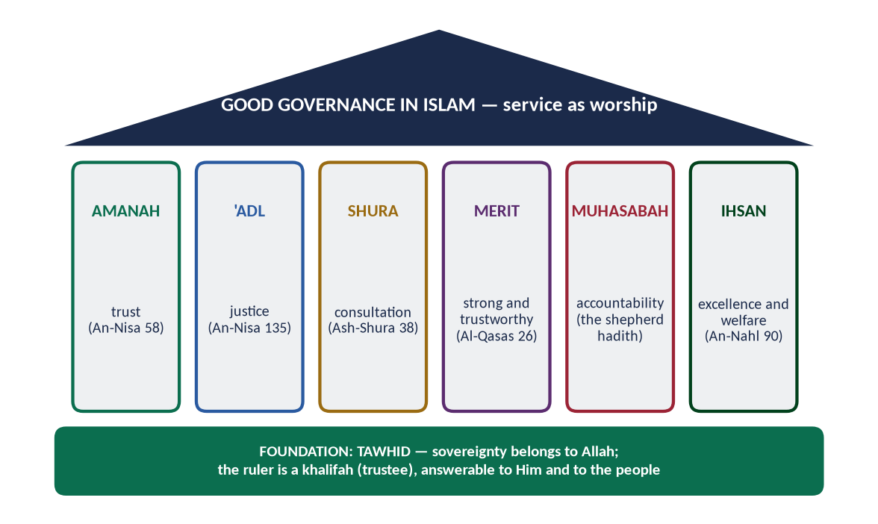
Figure 2 · The pillars of good governance in Islam.
- Tawhid: sovereignty belongs to Allah; the ruler is under the law.
- Amanah: the Prophet ﷺ refused office to Abu Dharr (RA): 'You are weak, and it is a trust' (Muslim).
- Justice for all (An-Nahl 90).
- Shura (Ash-Shura 38).
- Merit:
✦ QURAN
﴿قَالَتۡ إِحۡدَىٰهُمَا يَـٰٓأَبَتِ ٱسۡتَـٔۡجِرۡهُۖ إِنَّ خَيۡرَ مَنِ ٱسۡتَـٔۡجَرۡتَ ٱلۡقَوِيُّ ٱلۡأَمِينُ﴾
“One of the women said, "O my father, hire him. Indeed, the best one you can hire is the strong and the trustworthy.” (Al-Qasas, Quran)
➜ 'The best one you can hire is the strong and the trustworthy.'

- Accountability — 'each of you is a shepherd'.
- Accessibility:
✦ HADITH
مَنْ وَلَّاهُ اللَّهُ عَزَّ وَجَلَّ شَيْئًا مِنْ أَمْرِ الْمُسْلِمِينَ فَاحْتَجَبَ دُونَ حَاجَتِهِمْ ... احْتَجَبَ اللَّهُ عَنْهُ دُونَ حَاجَتِهِ
“Whoever is put in charge of the Muslims' affairs and shuts himself away from their needs, Allah will shut Himself away from his needs.” (Abu Dawud)

- Ihsan — excellence in work.

(v) The Prophet's ﷺ administration
The Prophet ﷺ built the first Islamic administration:
- the Charter of Madinah (622);
- governors and judges — Mu'adh ibn Jabal (RA) to Yemen, 'Attab ibn Asid (RA) to Makkah;
- secretaries such as Zayd ibn Thabit (RA);
- Zakat collectors, checked on their return;
- market inspection in person.
He asked Mu'adh how he would judge — 'by the Book of Allah, then the Sunnah, then my own Ijtihad' — and approved the answer (Abu Dawud and Al-Tirmidhi).

(vi) The Rashidun model
Hazrat Umar (RA) gave the state its machinery:
- provinces, each with a wali, qadi, treasurer and police;
- the Diwan (register of stipends);
- an independent judiciary;
- written conditions for governors — no doorkeeper, no luxury;
- a register of their wealth.

(3) The responsibilities of civil servants
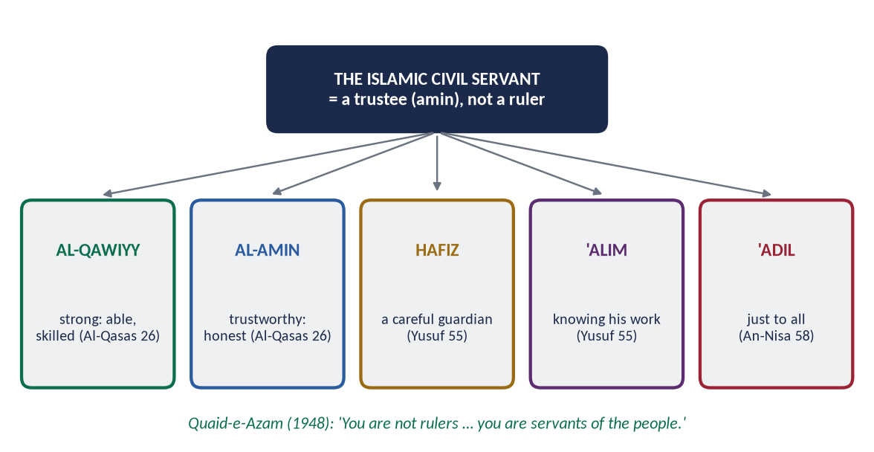
Figure 3 · The qualities of the Islamic civil servant.

(i) To treat the office as a trust
✦ QURAN
﴿يَـٰٓأَيُّهَا ٱلَّذِينَ ءَامَنُواْ لَا تَخُونُواْ ٱللَّهَ وَٱلرَّسُولَ وَتَخُونُوٓاْ أَمَٰنَٰتِكُمۡ وَأَنتُمۡ تَعۡلَمُونَ﴾
“O you who have believed, do not betray Allah and the Messenger or betray your trusts while you know [the consequence].” (Al-Anfal, Quran)
➜ Do not betray Allah and the Messenger, nor betray your trusts knowingly.

(ii) Honesty with public property
✦ HADITH
مَنِ اسْتَعْمَلْنَاهُ مِنْكُمْ عَلَى عَمَلٍ، فَكَتَمَنَا مِخْيَطًا فَمَا فَوْقَهُ، كَانَ غُلُولًا يَأْتِي بِهِ يَوْمَ الْقِيَامَةِ
“Whoever we appoint to a post and he hides from us a needle or more, it is embezzlement he will bring on the Day of Resurrection.” (Muslim)

(iii) No bribes and no gifts of office
✦ HADITH
لَعَنَ رَسُولُ اللَّهِ ﷺ الرَّاشِيَ وَالْمُرْتَشِيَ
“The Messenger of Allah ﷺ cursed the briber and the bribe-taker.” (Abu Dawud and Al-Tirmidhi)

When the Zakat collector Ibn al-Lutbiyyah kept 'gifts', the Prophet ﷺ asked, 'Why did he not sit in his father's house and see whether gifts would come to him?' (Al-Bukhari).

(iv) Merit and fairness in every appointment
'By Allah, we do not appoint anyone who asks for it' (Al-Bukhari and Muslim). Sifarish and nepotism betray the trust: 'when authority is given to those not fit for it, wait for the Hour' (Al-Bukhari).

(v) Justice to every citizen
✦ QURAN
﴿… وَلَا يَجۡرِمَنَّكُمۡ شَنَـَٔانُ قَوۡمٍ عَلَىٰٓ أَلَّا تَعۡدِلُواْۚ ٱعۡدِلُواْ هُوَ أَقۡرَبُ لِلتَّقۡوَىٰۖ …﴾
“Do not let the hatred of a people lead you to be unjust. Be just; that is nearer to righteousness.” (Al-Ma'idah, Quran)
➜ Do not let the hatred of a people lead you to injustice. Be just.

Ali (RA) told Malik al-Ashtar that every citizen is 'your brother in religion or your equal in creation'.

(vi) Service, access and gentleness
✦ HADITH
اللَّهُمَّ مَنْ وَلِيَ مِنْ أَمْرِ أُمَّتِي شَيْئًا فَشَقَّ عَلَيْهِمْ فَاشْقُقْ عَلَيْهِ
“O Allah, whoever takes charge of any affair of my Ummah and makes it hard for them, make it hard for him.” (Muslim)
➜ Red tape and delay are condemned.

(vii) Excellence and diligence
'Allah loves that when one of you does a job, he does it with perfection' (Al-Bayhaqi). Salary for time not worked is not lawful.

(viii) Obedience to lawful orders only
✦ HADITH
لَا طَاعَةَ فِي مَعْصِيَةٍ، إِنَّمَا الطَّاعَةُ فِي الْمَعْرُوفِ
“There is no obedience in disobedience; obedience is only in what is right.” (Al-Bukhari and Muslim)

(ix) Political neutrality and courage
✦ SCHOLARLY VIEW
Quaid-e-Azam Muhammad Ali Jinnah · Address to civil officers, Peshawar, 14 April 1948
“Do your duty as servants of the people and the State, fearlessly and honestly.”

(x) Keeping records and secrets
Accurate records and confidential information are trusts. Forgery is lying and betrayal.

(xi) Simplicity and no conflict of interest
When Umar's (RA) sons traded with a loan from the treasury, he made half the profit go to the treasury (Al-Muwatta').

(xii) Accountability
✦ HADITH
كُلُّكُمْ رَاعٍ وَكُلُّكُمْ مَسْئُولٌ عَنْ رَعِيَّتِهِ
“Each of you is a shepherd and each is responsible for his flock.” (Al-Bukhari and Muslim)

(4) The lesson for Pakistan
Pakistan's civil servants work under the Government Servants (Conduct) Rules (1964), which forbid gifts and require assets to be declared, and the Efficiency and Discipline Rules (2020). The rules exist; what is missing is the inner check of taqwa and freedom from political pressure — exactly what Islam supplies.
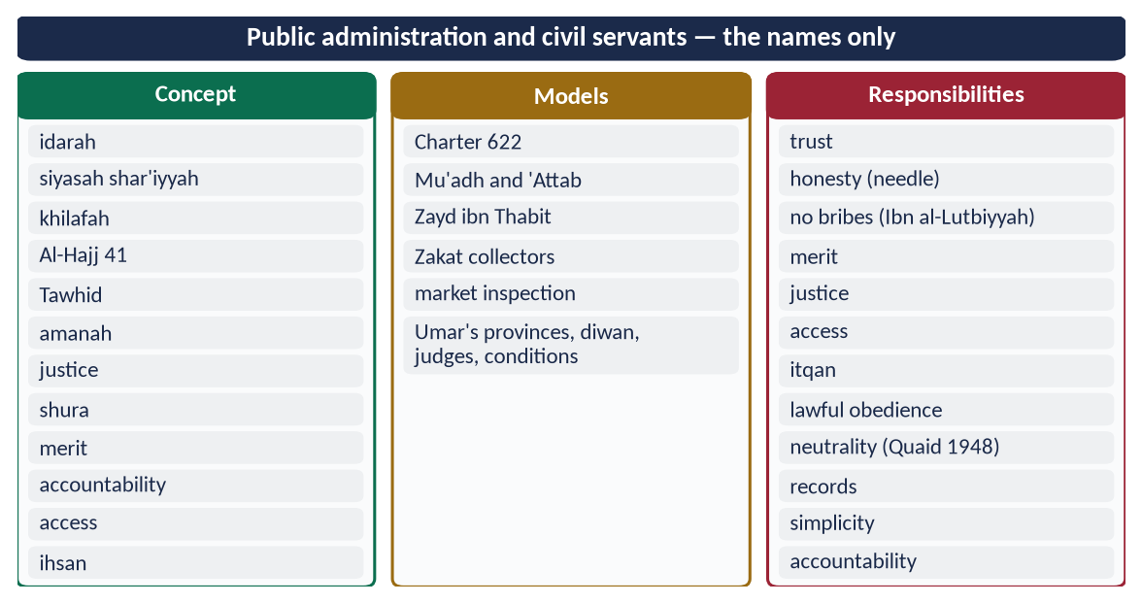
Figure 4 · At a glance — public administration and civil servants — the names only. The detail is in the sections above.

(5) Conclusion
✦ QURAN
﴿تِلۡكَ ٱلدَّارُ ٱلۡأٓخِرَةُ نَجۡعَلُهَا لِلَّذِينَ لَا يُرِيدُونَ عُلُوّٗا فِي ٱلۡأَرۡضِ وَلَا فَسَادٗاۚ وَٱلۡعَٰقِبَةُ لِلۡمُتَّقِينَ﴾
“That home of the Hereafter We assign to those who do not desire exaltedness upon the earth or corruption. And the [best] outcome is for the righteous.” (Al-Qasas, Quran)
➜ That home of the Hereafter We give to those who seek neither superiority on earth nor corruption.

Public administration in Islam is service performed as worship, under the sovereignty of Allah. The civil servant is its hand: honest, able, just, accessible and accountable. When the officer sees himself as a trustee and not a ruler, the state becomes what the Quran intends — a guardian of justice and welfare.

Why this answer scores
- Both limbs get full, separate headings.
- The concept is shown through principles and models: the Prophet ﷺ and Umar (RA).
- Twelve duties, each with a verse or hadith, applied to Pakistan's rules.

Answer 2 · The Salient Features of the Islamic Political System under the Pious Khilafat (CSS 2016)
THE QUESTION · CSS 2016 · Q7 · 20 marks
Discuss the salient features of Islamic political system in the light of governance under pious Khilafat-i-Rashida.

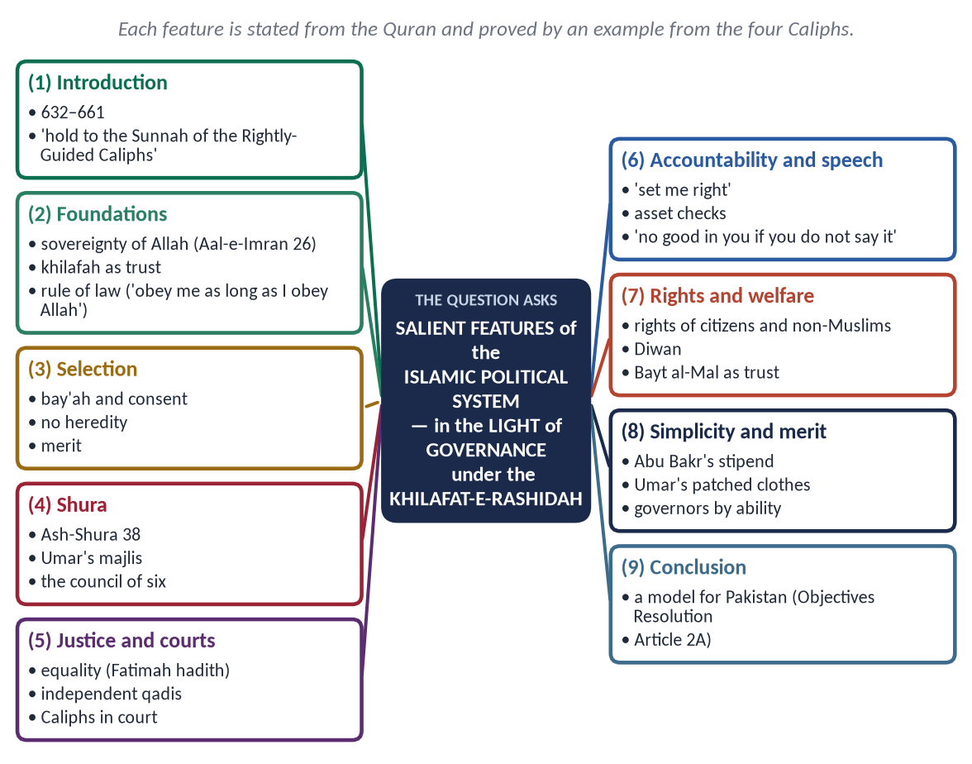
Figure 5 · The answer map: every branch is one numbered heading of the model answer below.

Decoding the question
- 'Salient features' — the main, distinguishing characteristics, numbered and explained.
- 'In the light of governance under pious Khilafat-i-Rashida' — each feature must be proved by the practice of the four Caliphs, not only stated in theory.

The model answer

(1) Introduction
The Khilafat-e-Rashidah (632–661) of Abu Bakr, Umar, Uthman and Ali (RA) is the practical model of the Islamic political system.
✦ HADITH
عَلَيْكُمْ بِسُنَّتِي وَسُنَّةِ الْخُلَفَاءِ الرَّاشِدِينَ الْمَهْدِيِّينَ
“Hold to my Sunnah and the Sunnah of the Rightly-Guided Caliphs.” (Abu Dawud and Al-Tirmidhi)

(2) The salient features

(i) Sovereignty of Allah
✦ QURAN
﴿قُلِ ٱللَّهُمَّ مَٰلِكَ ٱلۡمُلۡكِ تُؤۡتِي ٱلۡمُلۡكَ مَن تَشَآءُ وَتَنزِعُ ٱلۡمُلۡكَ مِمَّن تَشَآءُ …﴾
“Say: O Allah, Owner of sovereignty, You give sovereignty to whom You will and take sovereignty away from whom You will.” (Aal-e-Imran, Quran)
➜ Say: O Allah, Owner of sovereignty, You give sovereignty to whom You will.

The Caliphs saw themselves as executors of Allah's law, not its makers. Abu Bakr's first address:
✦ FROM THE SIRAH
أَطِيعُونِي مَا أَطَعْتُ اللَّهَ وَرَسُولَهُ، فَإِذَا عَصَيْتُ اللَّهَ وَرَسُولَهُ فَلَا طَاعَةَ لِي عَلَيْكُمْ
“Obey me as long as I obey Allah and His Messenger; if I disobey them, you owe me no obedience.” (Ibn Hisham)

(ii) Khilafah — authority as a trust
Umar (RA) said: 'I am to your wealth like the guardian of an orphan; if I am rich I take nothing, and if I am poor I take what is reasonable.' Power was a burden, not a prize.

(iii) Government by consent — election through bay'ah
- Abu Bakr — chosen at Saqifah, then confirmed by general bay'ah.
- Umar — nominated after consultation, then confirmed by bay'ah.
- Uthman — chosen by a council of six after Abd al-Rahman ibn Awf consulted the people.
- Ali — given a public bay'ah.
No Caliph named his son. Heredity was rejected.

(iv) Shura — consultation
✦ QURAN
﴿وَٱلَّذِينَ ٱسۡتَجَابُواْ لِرَبِّهِمۡ وَأَقَامُواْ ٱلصَّلَوٰةَ وَأَمۡرُهُمۡ شُورَىٰ بَيۡنَهُمۡ وَمِمَّا رَزَقۡنَٰهُمۡ يُنفِقُونَ﴾
“And those who have responded to their lord and established prayer and whose affair is [determined by] consultation among themselves, and from what We have provided them, they spend.” (Ash-Shura, Quran)
➜ Their affairs are by consultation among themselves.

Umar kept a majlis al-shura of senior Companions and held open meetings in the Mosque. The fate of the conquered lands of Iraq was settled only after days of debate. He said: 'There is no Khilafah without consultation.'

(v) Rule of law and equality
✦ HADITH
وَايْمُ اللَّهِ لَوْ أَنَّ فَاطِمَةَ بِنْتَ مُحَمَّدٍ سَرَقَتْ لَقَطَعْتُ يَدَهَا
“By Allah, if Fatimah the daughter of Muhammad stole, I would cut off her hand.” (Al-Bukhari and Muslim)

When a governor's son struck a Copt in Egypt, Umar let the Copt take his retaliation and asked: 'Since when have you enslaved people whose mothers bore them free?'

(vi) An independent judiciary
Umar appointed judges separate from governors — Shurayh in Kufa — and set out the rules of justice in his letter to Abu Musa al-Ash'ari: 'treat people equally in your look, your sitting and your justice'. The Caliphs themselves stood in court. Ali lost his own case over his armour before Qadi Shurayh.

(vii) Accountability of rulers
Abu Bakr: 'If I do wrong, set me right.' Umar:
- kept a register of governors' wealth;
- shared unexplained gains with the treasury;
- sent Muhammad ibn Maslamah to inquire;
- heard complaints against governors at Hajj.
Uthman answered his critics publicly in the Mosque.

(viii) Freedom of expression
When a man told Umar, 'Fear Allah!', and others objected, Umar said: 'There is no good in you if you do not say it, and no good in us if we do not hear it.'

(ix) Fundamental rights
Life, property, honour and belief were protected for all citizens.
✦ QURAN
﴿لَآ إِكۡرَاهَ فِي ٱلدِّينِۖ قَد تَّبَيَّنَ ٱلرُّشۡدُ مِنَ ٱلۡغَيِّۚ …﴾
“There is no compulsion in religion; the right course has become clear from the wrong.” (Al-Baqarah, Quran)
➜ 'There is no compulsion in religion.'

Umar's covenant with the people of Jerusalem (638) protected their churches and crosses.

(x) A welfare state
- Umar's Diwan gave stipends to all, even new-born children.
- An old Jewish beggar received a pension: 'We took jizyah from him in his youth; it is not just to abandon him in his old age' (Abu Yusuf, Kitab al-Kharaj).
- In the famine of 18 AH, Umar gave up meat and butter until the people could eat them again.

(xi) The public treasury as a trust
The Bayt al-Mal was kept separate from the Caliph's own money. Abu Bakr returned his stipend from his own property before his death. Ali gave equal shares and refused his own brother 'Aqil any extra.

(xii) Simplicity of rulers
Abu Bakr lived on a modest stipend fixed by the Companions. Umar wore patched clothes and slept in the open without guards. Ali lived plainly in Kufa.

(xiii) Merit and supervision of officials
Governors were chosen for ability and integrity, given written conditions (no doorkeeper, no luxury), and removed on complaint. Sa'd ibn Abi Waqqas was removed from Kufa to keep public trust.

(xiv) Protection of the weak
Abu Bakr's first address promised: 'The weak among you is strong with me until I secure his right; the strong among you is weak with me until I take from him the right he owes.' The state existed to protect those who could not protect themselves.
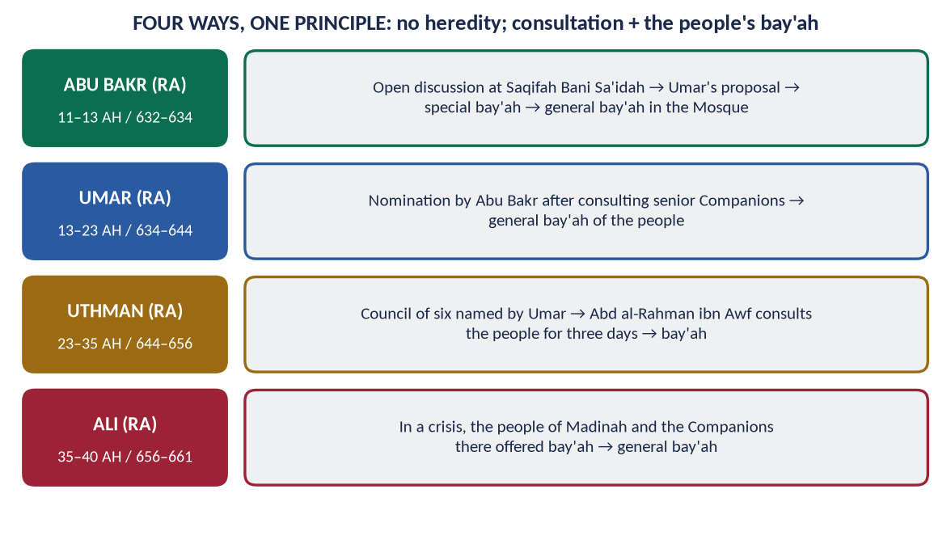
Figure 6 · Four ways of choosing the Caliph, one principle.
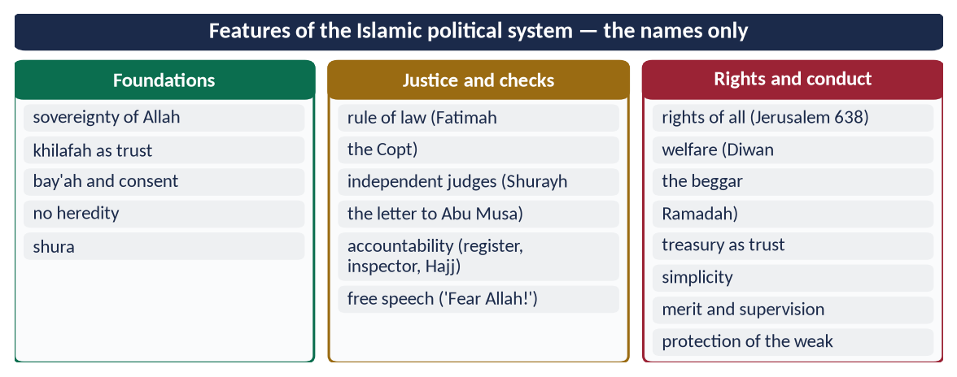
Figure 7 · At a glance — features of the Islamic political system — the names only. The detail is in the sections above.

(3) Relevance for Pakistan
The Objectives Resolution (1949) and Article 2A state the same principle: sovereignty belongs to Allah, and authority is a sacred trust exercised by the people's chosen representatives. Pakistan has the form. The Rashidun model asks for the substance: accountability from the top, merit, simplicity and justice for the weak.

(4) Conclusion
✦ QURAN
﴿وَعَدَ ٱللَّهُ ٱلَّذِينَ ءَامَنُواْ مِنكُمۡ وَعَمِلُواْ ٱلصَّـٰلِحَٰتِ لَيَسۡتَخۡلِفَنَّهُمۡ فِي ٱلۡأَرۡضِ كَمَا ٱسۡتَخۡلَفَ ٱلَّذِينَ مِن قَبۡلِهِمۡ …﴾
“Allah has promised those who believe and do righteous deeds that He will make them successors in the land, as He made those before them.” (An-Nur, Quran)
➜ Power is promised to faith and righteous deeds.

The Islamic political system, as the Rashidun practised it, rests on the sovereignty of Allah, the consent of the people, consultation, justice, accountability and welfare. It remains the standard by which every Muslim government is judged.

Why this answer scores
- Fourteen numbered features, each with a Rashidun example, exactly as 'in the light of governance under pious Khilafat' demands.
- Quran and Hadith first, then the Caliphs' practice.
- A short link to Pakistan's Constitution shows application.

Answer 3 · The Election of the Rightly-Guided Caliphs and How Far Their System Was Democratic (CSS 2017)
THE QUESTION · CSS 2017 · Q4 · 20 marks
How were the Rightly-guided Caliphs elected? To what extent their system of government be regarded as democratic?

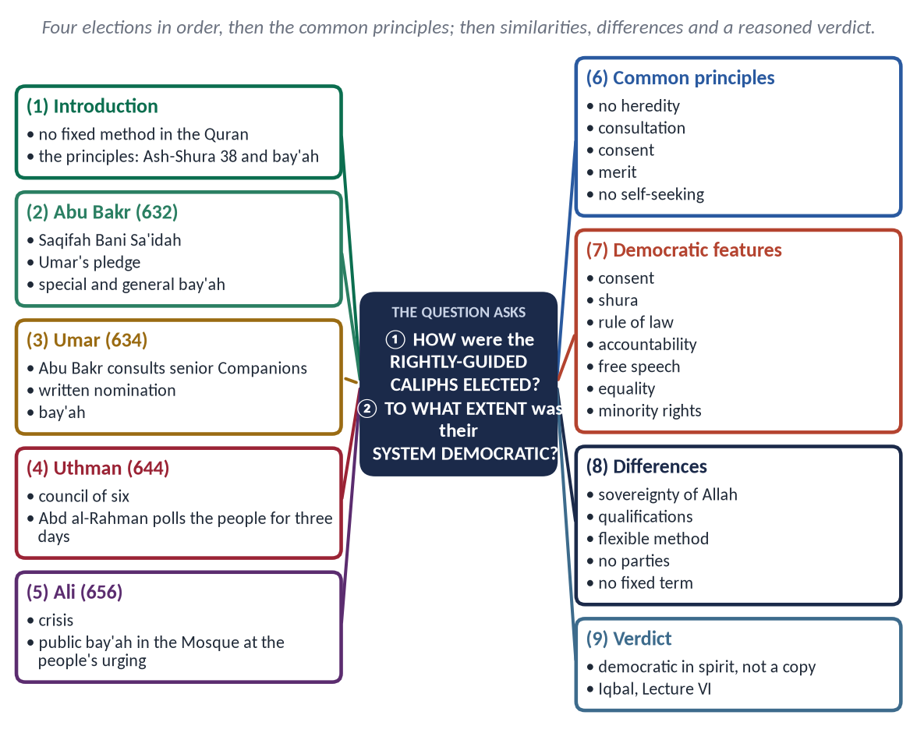
Figure 8 · The answer map: every branch is one numbered heading of the model answer below.

Decoding the question
- 'How were they elected?' — the process for each of the four, in order, and the principles common to them.
- 'To what extent … democratic?' — a measured judgement: similarities, differences, verdict. 'To what extent' forbids a one-word yes or no.

The model answer

(1) Introduction
The Quran did not fix one procedure for choosing a ruler. It fixed principles: consultation and consent.
✦ QURAN
﴿وَٱلَّذِينَ ٱسۡتَجَابُواْ لِرَبِّهِمۡ وَأَقَامُواْ ٱلصَّلَوٰةَ وَأَمۡرُهُمۡ شُورَىٰ بَيۡنَهُمۡ وَمِمَّا رَزَقۡنَٰهُمۡ يُنفِقُونَ﴾
“And those who have responded to their lord and established prayer and whose affair is [determined by] consultation among themselves, and from what We have provided them, they spend.” (Ash-Shura, Quran)
➜ Their affairs are by consultation among themselves.

The four Rightly-Guided Caliphs were each chosen differently, but always through consultation and the people's bay'ah (pledge of allegiance).

(2) How the Caliphs were elected
Figure 9 · The four elections of the Rightly-Guided Caliphs.

(i) Hazrat Abu Bakr (RA), 11 AH / 632 — open election
- On the Prophet's ﷺ death, the Ansar gathered at Saqifah Bani Sa'idah to choose a leader.
- Abu Bakr, Umar and Abu Ubaydah (RA) joined them, and there was open debate.
- Umar (RA) pledged allegiance to Abu Bakr, and those present followed. This was the special bay'ah.
- The next day the whole community gave the general bay'ah in the Prophet's Mosque.
- His merits were known: companion of the Cave (At-Tawbah 40), and leader of the prayers in the Prophet's ﷺ last illness.
✦ FROM THE SIRAH
فَإِنِّي قَدْ وُلِّيتُ عَلَيْكُمْ وَلَسْتُ بِخَيْرِكُمْ، فَإِنْ أَحْسَنْتُ فَأَعِينُونِي، وَإِنْ أَسَأْتُ فَقَوِّمُونِي
“I have been given authority over you, though I am not the best of you. If I do well, help me; if I do wrong, set me right.” (Ibn Hisham)

(ii) Hazrat Umar (RA), 13 AH / 634 — nomination after consultation
- In his last illness Abu Bakr consulted senior Companions, including Abd al-Rahman ibn Awf and Uthman (RA), about Umar.
- When some feared Umar's strictness, Abu Bakr replied that responsibility would soften him.
- The nomination was written and read to the people, who gave their bay'ah. It was a proposal, and it became valid by public consent.

(iii) Hazrat Uthman (RA), 23 AH / 644 — an electoral council
- The dying Umar named a council of six: Uthman, Ali, Talhah, Zubayr, Sa'd ibn Abi Waqqas and Abd al-Rahman ibn Awf (RA).
- He gave them three days, and barred his own son Abdullah from being chosen.
- Abd al-Rahman ibn Awf withdrew his own name and consulted the people for three days and nights. The majority preferred Uthman, and bay'ah was given in the Mosque.

(iv) Hazrat Ali (RA), 35 AH / 656 — public bay'ah in a crisis
- After Uthman's martyrdom, the Companions in Madinah and the people urged Ali to accept.
- He agreed only on condition that the bay'ah be public, in the Mosque, with the people's consent.

(v) The principles common to all four
- No hereditary succession.
- Consultation of the leading men.
- Consent of the people through bay'ah.
- Merit: knowledge, piety and experience.
- No one sought the office.
✦ HADITH
إِنَّا وَاللَّهِ لَا نُوَلِّي عَلَى هَذَا الْعَمَلِ أَحَدًا سَأَلَهُ، وَلَا أَحَدًا حَرَصَ عَلَيْهِ
“By Allah, we do not appoint to this work anyone who asks for it or is eager for it.” (Al-Bukhari and Muslim)

(3) To what extent was the system democratic?

(i) The democratic features
Democratic principle | Under the Rashidun
Government by consent | No Caliph without the people's bay'ah
Consultation / representation | Umar's majlis; the council of six; open meetings in the Mosque
Rule of law | The Caliph under the Shari'ah; 'obey me as long as I obey Allah'
Accountability | 'Set me right'; public questioning; asset checks of governors
Freedom of expression | 'No good in you if you do not say it' (Umar)
Equality before law | Ali lost his case before Qadi Shurayh
Rights of minorities | Covenant of Jerusalem (638)
No hereditary rule | None appointed his son; Umar barred his own

(ii) The differences from modern Western democracy
- Sovereignty. In democracy the people are sovereign and a majority can make any law. In Islam Allah is sovereign; the people hold authority as a trust and cannot vote to permit what Allah forbade.
- Qualifications. The Caliph needed knowledge, justice and integrity. Popularity alone was not enough.
- Procedure. There was no universal adult franchise, no ballot and no political parties. The electorate was the leading men of Madinah, with public confirmation.
- Term. There was no fixed term; a Caliph served while he remained just and able.
- Aim. The aim was not only the will of the majority but justice and the pleasure of Allah.

(iii) The verdict
The Rashidun system was democratic in spirit and essence: consent, consultation, accountability, rule of law, equality and rights. It was not democratic in form as the West knows it today, and it was superior in one respect: it bound the majority itself to a higher moral law.
✦ SCHOLARLY VIEW
Allama Muhammad Iqbal · The Reconstruction of Religious Thought in Islam, Lecture VI
“The republican form of government is not only thoroughly consistent with the spirit of Islam, but has also become a necessity in view of the new forces that are set free in the world of Islam.”

(4) The lesson for today
Because the Rashidun fixed the principles and left the procedure open, a modern Muslim state may use elections, parliaments and courts, as Pakistan's Article 2A envisages, provided it keeps consultation, accountability and the limits of Allah.
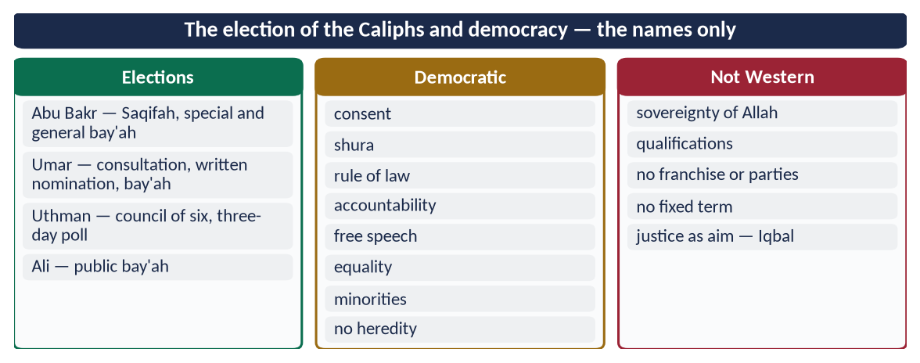
Figure 10 · At a glance — the election of the Caliphs and democracy — the names only. The detail is in the sections above.

(5) Conclusion
✦ QURAN
﴿فَبِمَا رَحۡمَةٖ مِّنَ ٱللَّهِ لِنتَ لَهُمۡۖ وَلَوۡ كُنتَ فَظًّا غَلِيظَ ٱلۡقَلۡبِ لَٱنفَضُّواْ مِنۡ حَوۡلِكَۖ …﴾
“So by mercy from Allah you were gentle with them; had you been harsh and hard-hearted, they would have scattered from around you.” (Aal-e-Imran, Quran)
➜ 'Consult them in the matter, and when you have decided, rely upon Allah.'

The Rightly-Guided Caliphs were chosen in four different ways with one spirit: consultation and consent, never heredity. Their system was a consultative, accountable and law-bound government — democratic in its values, divine in its limits.

Why this answer scores
- The four elections are narrated in order with names and dates, then reduced to principles.
- 'To what extent' is answered with similarities, differences and a verdict, not a one-word reply.
- Iqbal's judgement and Article 2A give authority and relevance.

Answer 4 · The Responsibilities of Civil Servants in the Light of Islamic Teachings (CSS 2018)
THE QUESTION · CSS 2018 · Q5 · 20 marks
Highlight the responsibilities of civil servants in the light of Islamic teachings.

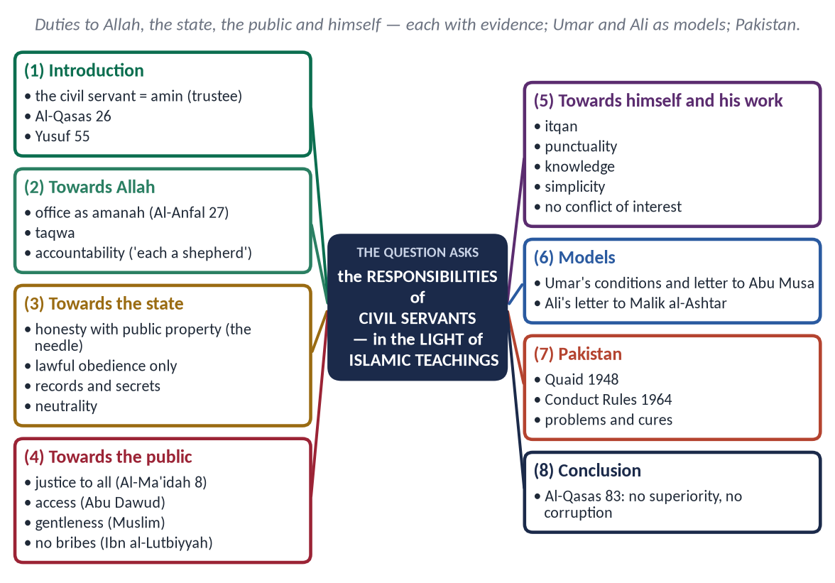
Figure 11 · The answer map: every branch is one numbered heading of the model answer below.

Decoding the question
- 'Responsibilities' — the duties of the civil servant, not the concept of administration (that was 2016's first limb).
- 'In the light of Islamic teachings' — every duty must rest on the Quran, Sunnah and the Caliphs' practice.
- This answer groups the duties by relationship, a different shape from Answer 1.

The model answer

(1) Introduction
A civil servant is a permanent official of the state who carries out its policies and serves its citizens. Islam calls him an 'amil and treats him as an amin (trustee). The Quran gives the two tests for every appointment:
✦ QURAN
﴿قَالَتۡ إِحۡدَىٰهُمَا يَـٰٓأَبَتِ ٱسۡتَـٔۡجِرۡهُۖ إِنَّ خَيۡرَ مَنِ ٱسۡتَـٔۡجَرۡتَ ٱلۡقَوِيُّ ٱلۡأَمِينُ﴾
“One of the women said, "O my father, hire him. Indeed, the best one you can hire is the strong and the trustworthy.” (Al-Qasas, Quran)
➜ 'The best one you can hire is the strong and the trustworthy.'

✦ QURAN
﴿قَالَ ٱجۡعَلۡنِي عَلَىٰ خَزَآئِنِ ٱلۡأَرۡضِۖ إِنِّي حَفِيظٌ عَلِيمٞ﴾
“[Joseph] said, "Appoint me over the storehouses of the land. Indeed, I will be a knowing guardian.” (Yusuf, Quran)
➜ Yusuf: 'Put me in charge of the storehouses of the land; I am a knowing guardian (hafiz 'alim).'

Strength (competence), trustworthiness (integrity), guardianship and knowledge: all four are needed.
Figure 12 · The qualities of the Islamic civil servant.

(2) Responsibilities towards Allah

(i) To see the office as a trust
✦ QURAN
﴿يَـٰٓأَيُّهَا ٱلَّذِينَ ءَامَنُواْ لَا تَخُونُواْ ٱللَّهَ وَٱلرَّسُولَ وَتَخُونُوٓاْ أَمَٰنَٰتِكُمۡ وَأَنتُمۡ تَعۡلَمُونَ﴾
“O you who have believed, do not betray Allah and the Messenger or betray your trusts while you know [the consequence].” (Al-Anfal, Quran)
➜ O you who believe, do not betray Allah and the Messenger, nor betray your trusts knowingly.

✦ HADITH
يَا أَبَا ذَرٍّ، إِنَّكَ ضَعِيفٌ، وَإِنَّهَا أَمَانَةٌ، وَإِنَّهَا يَوْمَ الْقِيَامَةِ خِزْيٌ وَنَدَامَةٌ، إِلَّا مَنْ أَخَذَهَا بِحَقِّهَا وَأَدَّى الَّذِي عَلَيْهِ فِيهَا
“O Abu Dharr, you are weak, and it is a trust; on the Day of Resurrection it is disgrace and regret — except for one who takes it by right and fulfils its duty.” (Muslim)

(ii) Taqwa — the inner auditor
✦ QURAN
﴿… وَهُوَ مَعَكُمۡ أَيۡنَ مَا كُنتُمۡۚ وَٱللَّهُ بِمَا تَعۡمَلُونَ بَصِيرٞ﴾
“And He is with you wherever you are; and Allah sees what you do.” (Al-Hadid, Quran)
➜ 'He is with you wherever you are, and Allah sees what you do.'

The fear of Allah is the check that works when no one is watching.

(iii) Accountability in the Hereafter
✦ HADITH
كُلُّكُمْ رَاعٍ وَكُلُّكُمْ مَسْئُولٌ عَنْ رَعِيَّتِهِ
“Each of you is a shepherd and each is responsible for his flock.” (Al-Bukhari and Muslim)

(3) Responsibilities towards the state

(i) Honesty with public money and property
✦ QURAN
﴿وَمَا كَانَ لِنَبِيٍّ أَن يَغُلَّۚ وَمَن يَغۡلُلۡ يَأۡتِ بِمَا غَلَّ يَوۡمَ ٱلۡقِيَٰمَةِۚ ثُمَّ تُوَفَّىٰ كُلُّ نَفۡسٖ مَّا كَسَبَتۡ وَهُمۡ لَا يُظۡلَمُونَ﴾
“It is not [attributable] to any prophet that he would act unfaithfully [in regard to war booty]. And whoever betrays, [taking unlawfully], will come with what he took on the Day of Resurrection. Then will every soul be [fully] compensated for what it earned, and they will not be wronged.” (Aal-e-Imran, Quran)
➜ Whoever betrays will bring what he took on the Day of Resurrection.

✦ HADITH
مَنِ اسْتَعْمَلْنَاهُ مِنْكُمْ عَلَى عَمَلٍ، فَكَتَمَنَا مِخْيَطًا فَمَا فَوْقَهُ، كَانَ غُلُولًا
“Whoever we appoint to a post and he hides from us a needle or more, that is embezzlement.” (Muslim)
➜ Official cars, offices and funds are not private property.

(ii) Obedience to lawful orders — refusal of unlawful ones
✦ HADITH
لَا طَاعَةَ فِي مَعْصِيَةٍ، إِنَّمَا الطَّاعَةُ فِي الْمَعْرُوفِ
“No obedience in disobedience; obedience is only in what is right.” (Al-Bukhari and Muslim)

✦ QURAN
﴿يَـٰٓأَيُّهَا ٱلَّذِينَ ءَامَنُوٓاْ أَطِيعُواْ ٱللَّهَ وَأَطِيعُواْ ٱلرَّسُولَ وَأُوْلِي ٱلۡأَمۡرِ مِنكُمۡۖ …﴾
“Obey Allah and obey the Messenger and those in authority among you.” (An-Nisa, Quran)
➜ Obedience to the state is a duty, within the law.

(iii) Keeping records and official secrets
Records must be true and secrets kept. The Prophet ﷺ had secretaries (Zayd ibn Thabit), and Umar kept the Diwan. A false entry is lying and a leaked secret is betrayal.

(iv) Political neutrality and loyalty to the Constitution
The civil servant serves the state, whichever party governs.
✦ SCHOLARLY VIEW
Quaid-e-Azam Muhammad Ali Jinnah · Address to civil officers, Peshawar, 14 April 1948
“You should not be influenced by any political pressure, by any political party or individual politician … do your duty as servants of the people and the State, fearlessly and honestly.”

(4) Responsibilities towards the public

(i) Justice and equal treatment
✦ QURAN
﴿… وَلَا يَجۡرِمَنَّكُمۡ شَنَـَٔانُ قَوۡمٍ عَلَىٰٓ أَلَّا تَعۡدِلُواْۚ ٱعۡدِلُواْ هُوَ أَقۡرَبُ لِلتَّقۡوَىٰۖ …﴾
“Do not let the hatred of a people lead you to be unjust. Be just; that is nearer to righteousness.” (Al-Ma'idah, Quran)
➜ Do not let the hatred of a people lead you to injustice. Be just; that is nearer to righteousness.

Ali (RA) told Malik al-Ashtar that every citizen is 'your brother in religion or your equal in creation'. There must be no discrimination by religion, sect, language, province or party.

(ii) Accessibility — the open door
✦ HADITH
مَنْ وَلَّاهُ اللَّهُ عَزَّ وَجَلَّ شَيْئًا مِنْ أَمْرِ الْمُسْلِمِينَ فَاحْتَجَبَ دُونَ حَاجَتِهِمْ وَخَلَّتِهِمْ وَفَقْرِهِمْ، احْتَجَبَ اللَّهُ عَنْهُ دُونَ حَاجَتِهِ وَخَلَّتِهِ وَفَقْرِهِ
“Whoever is put in charge of the Muslims' affairs and shuts himself away from their needs and poverty, Allah will shut Himself away from his needs and poverty.” (Abu Dawud)

Umar (RA) forbade his governors to keep a doorkeeper.

(iii) Gentleness and ease
✦ HADITH
وَمَنْ وَلِيَ مِنْ أَمْرِ أُمَّتِي شَيْئًا فَرَفَقَ بِهِمْ فَارْفُقْ بِهِ
“… and whoever takes charge of any affair of my Ummah and is gentle with them, (O Allah) be gentle with him.” (Muslim)
➜ Courtesy, quick decisions and simple procedures.

(iv) No bribes and no 'gifts'
✦ HADITH
لَعَنَ رَسُولُ اللَّهِ ﷺ الرَّاشِيَ وَالْمُرْتَشِيَ
“The Messenger of Allah ﷺ cursed the briber and the bribe-taker.” (Abu Dawud and Al-Tirmidhi)

To the Zakat collector Ibn al-Lutbiyyah: 'Why did he not sit in his father's house and see whether gifts would come to him?' (Al-Bukhari).

(v) Merit in the service of others
Posts, contracts and admissions must go to the deserving.
✦ HADITH
إِذَا وُسِّدَ الْأَمْرُ إِلَى غَيْرِ أَهْلِهِ فَانْتَظِرِ السَّاعَةَ
“When authority is given to those not fit for it, then wait for the Hour.” (Al-Bukhari)

(5) Responsibilities towards himself and his work
- Excellence (itqan): 'Allah loves that when one of you does a job, he does it with perfection' (Al-Bayhaqi).
- Punctuality and diligence: a salaried officer (in Hanafi fiqh, an ajir khass) owes his working hours. Pay for time not worked is doubtful.
- Knowledge: the 'alim of Yusuf 55 — training and skill in his field.
- Simplicity: Umar's governors were forbidden luxury.
- No conflict of interest: when Umar's own sons profited from a treasury loan, half the profit went to the treasury (Al-Muwatta').

(6) The models — Umar and Ali (RA)
- Umar's letter to Abu Musa al-Ash'ari: 'Treat people equally in your look, your sitting and your justice, so that the noble do not hope for your partiality and the weak do not despair of your justice.'
- Umar's instruction to governors: 'I have not sent you as tyrants, but as leaders of guidance … do not shut your doors against them' (Kitab al-Kharaj).
- Ali's letter to Malik al-Ashtar: appoint officials by test, not favour; pay them enough to stay honest; watch them through trustworthy inspectors; give time to the poor yourself.

(7) Pakistan — the problem and the cure
Problem in Pakistan's service | Islamic teaching
Corruption, 'speed money' | The needle hadith; the briber and bribe-taker cursed
Sifarish and political postings | 'We do not appoint anyone who asks'; Al-Qasas 26
Delays and red tape | 'Whoever makes it hard for them …'
Colonial 'ruler' attitude | Quaid: 'you do not belong to the ruling class'
Pressure from above | 'No obedience in disobedience'
Absenteeism | Itqan; the hours of the ajir khass

The Government Servants (Conduct) Rules (1964) already forbid gifts and require assets to be declared. Islam adds the conscience that makes the rules work.
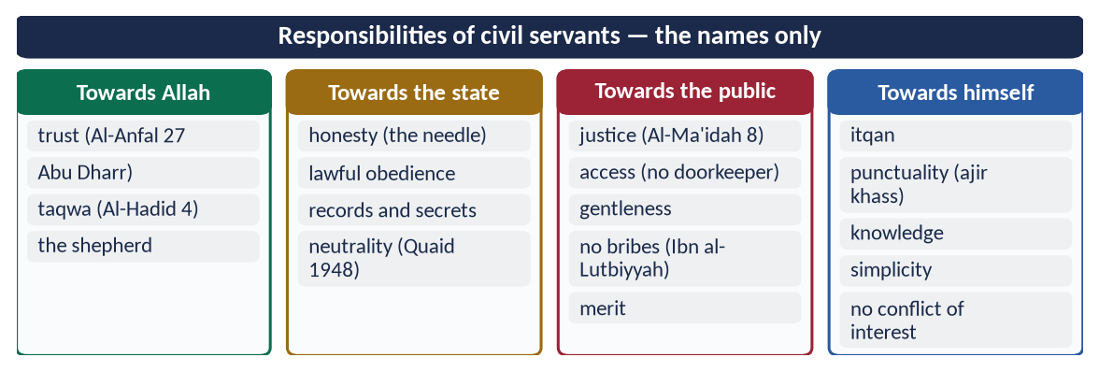
Figure 13 · At a glance — responsibilities of civil servants — the names only. The detail is in the sections above.

(8) Conclusion
✦ QURAN
﴿تِلۡكَ ٱلدَّارُ ٱلۡأٓخِرَةُ نَجۡعَلُهَا لِلَّذِينَ لَا يُرِيدُونَ عُلُوّٗا فِي ٱلۡأَرۡضِ وَلَا فَسَادٗاۚ وَٱلۡعَٰقِبَةُ لِلۡمُتَّقِينَ﴾
“That home of the Hereafter We assign to those who do not desire exaltedness upon the earth or corruption. And the [best] outcome is for the righteous.” (Al-Qasas, Quran)
➜ That home of the Hereafter We give to those who seek neither superiority on earth nor corruption.

The Islamic civil servant owes duties to Allah, to the state, to the public and to himself. He must be strong and trustworthy, a knowing guardian, just, accessible and honest. When Pakistan's officers see their office as a trust and not a throne, the civil service becomes what the Quaid wanted: 'servants of the people'.

Why this answer scores
- Duties grouped by four relationships, a clear and original structure.
- Every duty has a verse or hadith; Umar and Ali supply models.
- A Pakistan table turns teaching into application.

Answer 5 · Reforming Pakistani Politics in the Light of the Islamic Political System (CSS 2019)
THE QUESTION · CSS 2019 · Q8 · 20 marks
Give suggestions to reform Pakistani Politics keeping in view the different aspects of political system of Islam.

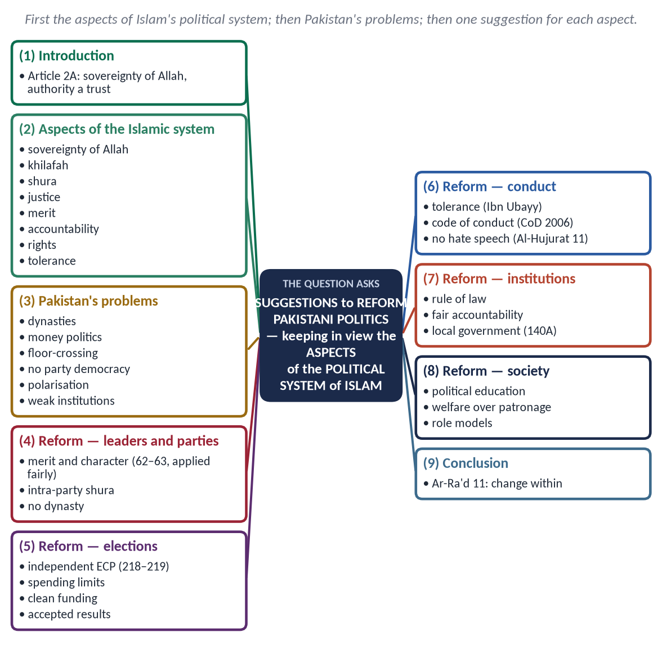
Figure 14 · The answer map: every branch is one numbered heading of the model answer below.

Decoding the question
- 'Suggestions to reform' — the answer must be practical. Suggestions form the major part.
- 'Keeping in view the different aspects of the political system of Islam' — first state those aspects briefly, then link each suggestion to an aspect.
- Stay neutral: criticise practices, not parties.

The model answer

(1) Introduction
Pakistan was created in the name of Islam, and its Constitution opens with the Objectives Resolution (Article 2A): sovereignty belongs to Allah, and authority is a sacred trust exercised by the people's chosen representatives. Yet its politics suffers from dynasties, money, polarisation and instability. The political system of Islam offers a measure and a cure.

(2) The aspects of the political system of Islam
Figure 15 · The pillars of good governance in Islam.
- Sovereignty of Allah and rule of law — 'Obey me as long as I obey Allah' (Abu Bakr).
- Khilafah — authority as a trust (An-Nisa 58).
- Shura — 'their affairs are by consultation' (Ash-Shura 38).
- Selection by consent and merit — the bay'ah; no heredity.
- Justice and equality — the Fatimah hadith.
- Accountability — 'set me right'.
- Rights and tolerance — the Charter of Madinah.
- Welfare — Al-Hajj 41; Umar's Diwan.

(3) The problems of Pakistani politics
Problem | Islamic aspect violated
Dynastic, hereditary party leadership | No heredity; merit
Money politics, vote-buying, 'electables' | Bribery cursed; office not for those who seek it
Floor-crossing and horse-trading | Keeping covenants (Al-Ma'idah 1)
No democracy inside parties | Shura
Hate speech, abuse, polarisation | 'Do not mock … do not insult' (Al-Hujurat 11)
Disputed elections; street agitation | Rule of law; 'no harm' (Ibn Majah)
Selective accountability | Equality before law
Imbalance among institutions | Every power under the Constitution
Neglect of local government | Umar's provinces with real powers

(4) Suggestions for reform

(i) Merit and character in leaders
✦ QURAN
﴿إِنَّ ٱللَّهَ يَأۡمُرُكُمۡ أَن تُؤَدُّواْ ٱلۡأَمَٰنَٰتِ إِلَىٰٓ أَهۡلِهَا وَإِذَا حَكَمۡتُم بَيۡنَ ٱلنَّاسِ أَن تَحۡكُمُواْ بِٱلۡعَدۡلِۚ …﴾
“Indeed, Allah commands you to render trusts to those entitled to them, and when you judge between people, to judge with justice.” (An-Nisa, Quran)
➜ Render trusts to those entitled to them.

Parties should nominate honest, able candidates, not only 'electables'. The qualifications in Articles 62–63 should be applied fairly through courts, never as a political weapon.

(ii) Shura inside parties — an end to dynastic politics
✦ QURAN
﴿وَٱلَّذِينَ ٱسۡتَجَابُواْ لِرَبِّهِمۡ وَأَقَامُواْ ٱلصَّلَوٰةَ وَأَمۡرُهُمۡ شُورَىٰ بَيۡنَهُمۡ وَمِمَّا رَزَقۡنَٰهُمۡ يُنفِقُونَ﴾
“And those who have responded to their lord and established prayer and whose affair is [determined by] consultation among themselves, and from what We have provided them, they spend.” (Ash-Shura, Quran)
➜ Their affairs are by consultation among themselves.

The Rashidun refused heredity; Umar barred even his own son. Parties need genuine intra-party elections and leadership chosen by members.

(iii) Clean and trusted elections
- An independent, empowered Election Commission (Articles 218–219).
- Strict spending limits and transparent party funding.
- Technology and procedures agreed by all parties.
- The losers accept the result; disputes go to tribunals, not the streets.
✦ HADITH
لَعَنَ رَسُولُ اللَّهِ ﷺ الرَّاشِيَ وَالْمُرْتَشِيَ
“The Messenger of Allah ﷺ cursed the briber and the bribe-taker.” (Abu Dawud and Al-Tirmidhi)
➜ Vote-buying is bribery.

(iv) Keeping covenants — against floor-crossing
✦ QURAN
﴿… وَأَوۡفُواْ بِٱلۡعَهۡدِۖ إِنَّ ٱلۡعَهۡدَ كَانَ مَسۡـُٔولٗا﴾
“And fulfil every commitment; indeed, the commitment will be questioned about.” (Al-Isra, Quran)
➜ Fulfil every commitment; every commitment will be questioned.

A member elected on a party's promise should keep it. Article 63A (defection) should be respected.

(v) Tolerance and a code of political conduct
✦ QURAN
﴿… لَا يَسۡخَرۡ قَوۡمٞ مِّن قَوۡمٍ عَسَىٰٓ أَن يَكُونُواْ خَيۡرٗا مِّنۡهُمۡ وَلَا نِسَآءٞ مِّن نِّسَآءٍ عَسَىٰٓ أَن يَكُنَّ خَيۡرٗا مِّنۡهُنَّۖ …﴾
“Let not a people ridicule another people — perhaps they are better than them; nor let women ridicule other women — perhaps they are better than them.” (Al-Hujurat, Quran)
➜ Do not mock one another, nor call one another by offensive names.

The Prophet ﷺ tolerated even Abdullah ibn Ubayy, leader of the hypocrites. All parties should agree a charter of conduct, as the Charter of Democracy (2006) showed is possible: no abuse, no hate speech, and respect for opponents' dignity.

(vi) Rule of law and the supremacy of the Constitution
✦ HADITH
لَوْ أَنَّ فَاطِمَةَ بِنْتَ مُحَمَّدٍ سَرَقَتْ لَقَطَعْتُ يَدَهَا
“If Fatimah the daughter of Muhammad stole, I would cut off her hand.” (Al-Bukhari and Muslim)

Every institution must work within its constitutional sphere (Articles 5 and 6). No person or body should be above the law.

(vii) Fair accountability
Accountability for all, by an independent body, with due process: 'do not judge for the first until you hear the other' (Al-Tirmidhi). Otherwise it becomes victimisation.

(viii) Empowered local government
Umar ran a vast state through provinces with real powers. Article 140A requires elected local governments with political, administrative and financial authority. Regular local elections would bring government to the people.

(ix) Welfare politics instead of patronage
✦ QURAN
﴿… كَيۡ لَا يَكُونَ دُولَةَۢ بَيۡنَ ٱلۡأَغۡنِيَآءِ مِنكُمۡۚ …﴾
“… so that it does not circulate only among the rich among you.” (Al-Hashr, Quran)
➜ So that wealth does not circulate only among the rich.

Parties should compete on policies — education, health, jobs — not on personal favours, jobs for supporters or development funds for loyalists.

(x) Political education and role models
Teach the Seerah's political ethics (shura, justice, tolerance, trust) in schools and party training. Leaders should live simply, like Abu Bakr on his modest stipend, and lead by example.

(xi) A neutral civil service and police
The Quaid told officers in 1948 to serve 'fearlessly and honestly' and not to yield to 'any political party or individual politician'. Fixed tenures, transfers only through independent boards, and promotion on performance would free the bureaucracy and police from political use. Then the state would serve all citizens equally, whichever party governs.
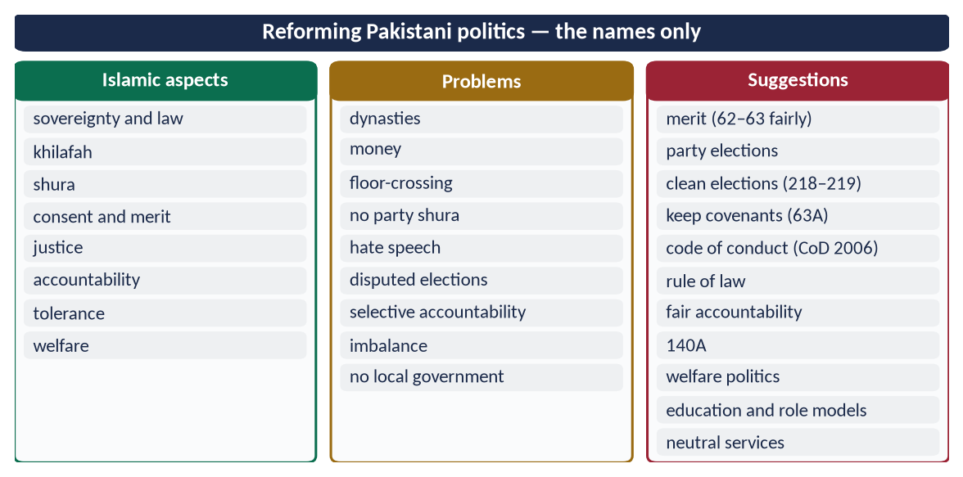
Figure 16 · At a glance — reforming Pakistani politics — the names only. The detail is in the sections above.

(5) Conclusion
✦ QURAN
﴿… إِنَّ ٱللَّهَ لَا يُغَيِّرُ مَا بِقَوۡمٍ حَتَّىٰ يُغَيِّرُواْ مَا بِأَنفُسِهِمۡۗ …﴾
“Indeed, Allah will not change the condition of a people until they change what is in themselves.” (Ar-Ra'd, Quran)
➜ Allah does not change the condition of a people until they change what is in themselves.

The political system of Islam gives Pakistan both a mirror and a map: sovereignty of Allah, trust, consultation, merit, justice and accountability. Reform begins when parties practise shura within, leaders live by the trust they hold, and every institution bows to the Constitution.

Why this answer scores
- It first sets out the aspects of the Islamic system that the question names.
- A problem–aspect table diagnoses Pakistan's politics neutrally.
- Eleven concrete suggestions, each tied to a verse or hadith and to the Constitution (62–63, 63A, 140A, 218–219).

Answer 6 · The Bravery and Juridical Wisdom of Hazrat Ali (RA) (CSS 2020)
THE QUESTION · CSS 2020 · Q3 · 20 marks
Write a comprehensive note on the bravery and juridical wisdom of Hazrat Ali (R.A).

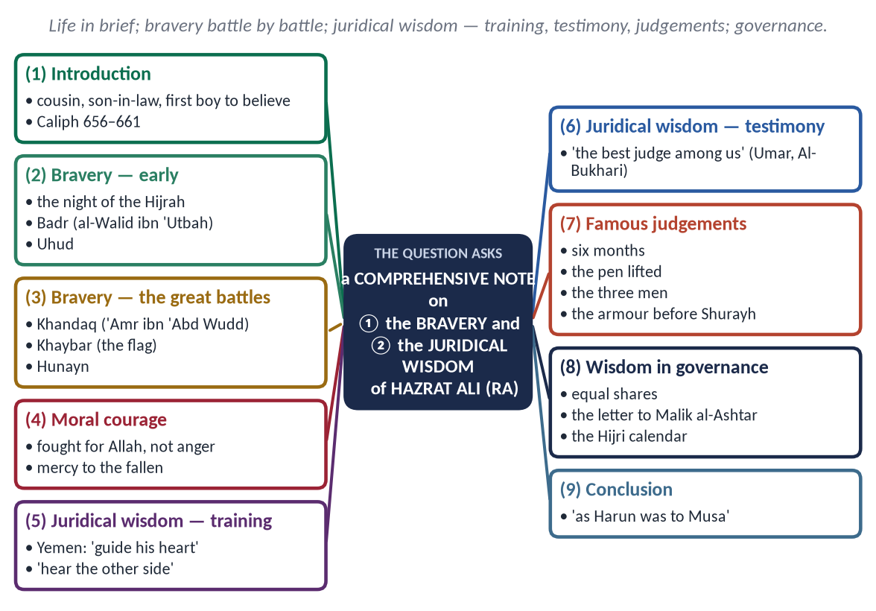
Figure 17 · The answer map: every branch is one numbered heading of the model answer below.

Decoding the question
- 'Comprehensive note' — full coverage with a short introduction and conclusion.
- Two qualities: bravery (physical and moral courage) and juridical wisdom (skill in law and judging). Give each its own main heading, with named events and cases.

The model answer

(1) Introduction
Ali ibn Abi Talib (RA) was the Prophet's ﷺ cousin and son-in-law, the husband of Fatimah (RA), and the father of Hasan and Husayn (RA). He was the first boy to accept Islam and grew up in the Prophet's ﷺ house. He was the fourth Rightly-Guided Caliph (656–661). Two qualities made him unique: the courage of a lion (hence his title Asadullah) and the wisdom of a judge.

(2) The bravery of Hazrat Ali (RA)

(i) The night of the Hijrah (622)
When the Quraysh surrounded the Prophet's ﷺ house to kill him, Ali slept in his bed, knowing the danger. He then stayed behind to return the trusts the Makkans had left with the Prophet ﷺ.

(ii) Badr (2 AH)
In the single combats that opened the battle, Ali killed al-Walid ibn 'Utbah and helped Hamzah and 'Ubaydah (RA). He was among the foremost fighters of the day.

(iii) Uhud (3 AH)
When the archers' mistake turned the battle and many scattered, Ali stood firm around the Prophet ﷺ, defending him and receiving many wounds.

(iv) Khandaq (5 AH)
'Amr ibn 'Abd Wudd, the most feared warrior of Arabia, crossed the trench and challenged the Muslims. Ali, still young, answered the challenge and killed him in single combat, breaking the confidence of the besiegers.

(v) Khaybar (7 AH)
After the fortresses had resisted for days, the Prophet ﷺ said:
✦ HADITH
لَأُعْطِيَنَّ الرَّايَةَ غَدًا رَجُلًا يُحِبُّ اللَّهَ وَرَسُولَهُ، وَيُحِبُّهُ اللَّهُ وَرَسُولُهُ، يَفْتَحُ اللَّهُ عَلَى يَدَيْهِ
“Tomorrow I will give the flag to a man who loves Allah and His Messenger, and whom Allah and His Messenger love; Allah will give victory at his hands.” (Al-Bukhari and Muslim)

The flag went to Ali, and the strong fortress of al-Qamus fell.

(vi) Hunayn (8 AH) and Tabuk (9 AH)
At Hunayn he was among the few who stood firm when the army first fled. At Tabuk he was left in charge of Madinah.
✦ HADITH
أَمَا تَرْضَى أَنْ تَكُونَ مِنِّي بِمَنْزِلَةِ هَارُونَ مِنْ مُوسَى، إِلَّا أَنَّهُ لَا نَبِيَّ بَعْدِي
“Are you not pleased to be to me as Harun was to Musa, except that there is no prophet after me?” (Al-Bukhari and Muslim)

(vii) Moral courage — bravery with justice
His courage was for Allah, not for anger. It is reported that when a fallen enemy spat at him, he held back his sword so as not to kill for a personal reason. As Caliph he ordered that the wounded not be killed nor the fleeing pursued, and he refused to call even his armed opponents disbelievers. This is the courage of self-control.

(3) The juridical wisdom of Hazrat Ali (RA)

(i) The Prophet's ﷺ training
When sent to Yemen as a judge, the young Ali worried that he lacked experience. The Prophet ﷺ struck his chest and prayed: 'O Allah, guide his heart and make his tongue firm' (Abu Dawud). He also taught him the first rule of natural justice:
✦ HADITH
إِذَا تَقَاضَى إِلَيْكَ رَجُلَانِ فَلَا تَقْضِ لِلْأَوَّلِ حَتَّى تَسْمَعَ كَلَامَ الْآخَرِ، فَسَوْفَ تَدْرِي كَيْفَ تَقْضِي
“When two men bring a case to you, do not judge for the first until you have heard the other; then you will know how to judge.” (Al-Tirmidhi)

(ii) The testimony of the Companions
✦ FROM THE SIRAH
أَقْرَؤُنَا أُبَيٌّ، وَأَقْضَانَا عَلِيٌّ
“The best reciter among us is Ubayy, and the best judge among us is Ali.” (Al-Bukhari)
➜ Said by Hazrat Umar (RA), who often consulted him on hard cases.

(iii) Famous judgements
Case | Ali's (RA) reasoning
Six months of pregnancy | A woman gave birth six months after marriage. Joining Al-Ahqaf 15 ('pregnancy and weaning thirty months') with Luqman 14 ('weaning in two years') shows that pregnancy can be six months; she was spared. (Some reports give the reasoning to Ibn Abbas.)
The insane woman | Brought for punishment, she was released when Ali reminded Umar: 'The pen is lifted from three — the sleeper, the child and the insane' (Abu Dawud) — the principle of legal capacity.
The three men and one child | In Yemen, three men claimed one child. Ali cast lots and made the winner pay two-thirds of the blood-money to the others; the Prophet ﷺ laughed at his ingenuity (Abu Dawud).
His own armour | As Caliph he sued a man over his armour before Qadi Shurayh; his witnesses (his son and his servant) were not accepted, and the Caliph lost. The man, moved by this justice, returned it and accepted Islam (reported by Abu Nu'aym and Al-Bayhaqi).

(iv) Wisdom in governance
- Equal distribution from the treasury; he refused his own brother 'Aqil any extra.
- He proposed dating the calendar from the Hijrah (17 AH).
- His letter to Malik al-Ashtar, governor of Egypt (38 AH), is a classic of administration:
✦ FROM THE SIRAH
فَإِنَّهُمْ صِنْفَانِ: إِمَّا أَخٌ لَكَ فِي الدِّينِ، وَإِمَّا نَظِيرٌ لَكَ فِي الْخَلْقِ
“People are of two kinds: either your brother in religion or your equal in creation.” (Nahj al-Balaghah, Letter 53)

It tells the governor to:
- choose judges who are patient, well paid and independent;
- appoint officials by test, not favour;
- care for the land before the tax;
- stop hoarding;
- give time to the poor himself.

(v) Knowledge and sayings
He guided Abu al-Aswad al-Du'ali in laying the foundations of Arabic grammar. Two of his sayings: 'Knowledge is better than wealth: knowledge guards you, while you guard wealth'; and 'The value of every person is in what he does well.'
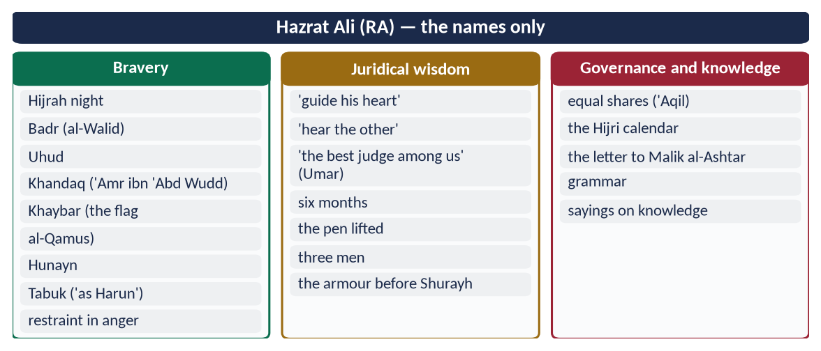
Figure 18 · At a glance — hazrat Ali (RA) — the names only. The detail is in the sections above.

(4) Conclusion
Hazrat Ali (RA) joined in one person the two things every state needs: the courage to defend what is right and the wisdom to judge what is right. His sword served justice, and his justice was stronger than his sword. The Caliph who lost a case in his own court remains a lesson for every ruler and judge in Pakistan: no one is above the law.

Why this answer scores
- Both qualities get full headings; bravery is shown battle by battle with named opponents.
- Juridical wisdom has training, testimony and cases in a table — 'comprehensive' in fact.
- Authentic evidence (Al-Bukhari, Muslim, Abu Dawud, Al-Tirmidhi) and a lesson for today.

Answer 7 · The Principles of Accountability of Rulers in the Quran and Sunnah (CSS 2021)
THE QUESTION · CSS 2021 · Q6 · 20 marks
Express the principles of accountability of rulers according to the Holy Quran and Sunnah.

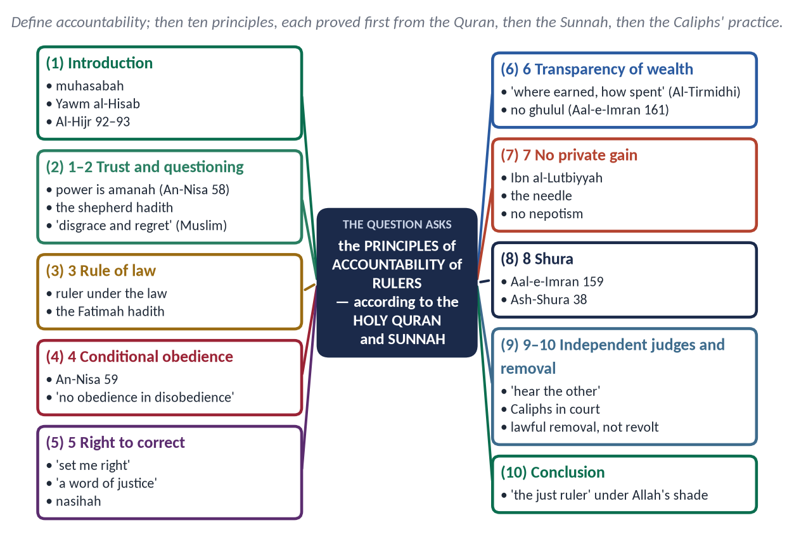
Figure 19 · The answer map: every branch is one numbered heading of the model answer below.

Decoding the question
- 'Express the principles' — state them as numbered principles, each clearly worded.
- 'According to the Holy Quran and Sunnah' — every principle needs a verse and a hadith; the Caliphs' practice may illustrate them.
- 'Rulers' — the focus is on those in power, not the individual Muslim in general.

The model answer

(1) Introduction
Accountability (muhasabah, مُحَاسَبَة) means that whoever holds power must answer for its use. In Islam every ruler answers first to Allah, and then to the law and the people.
✦ QURAN
﴿فَوَرَبِّكَ لَنَسۡـَٔلَنَّهُمۡ أَجۡمَعِينَ ۝ عَمَّا كَانُواْ يَعۡمَلُونَ﴾
“So by your Lord, We will surely question them all. About what they used to do.” (Al-Hijr, Quran)
➜ By your Lord, We will surely question them all about what they used to do.

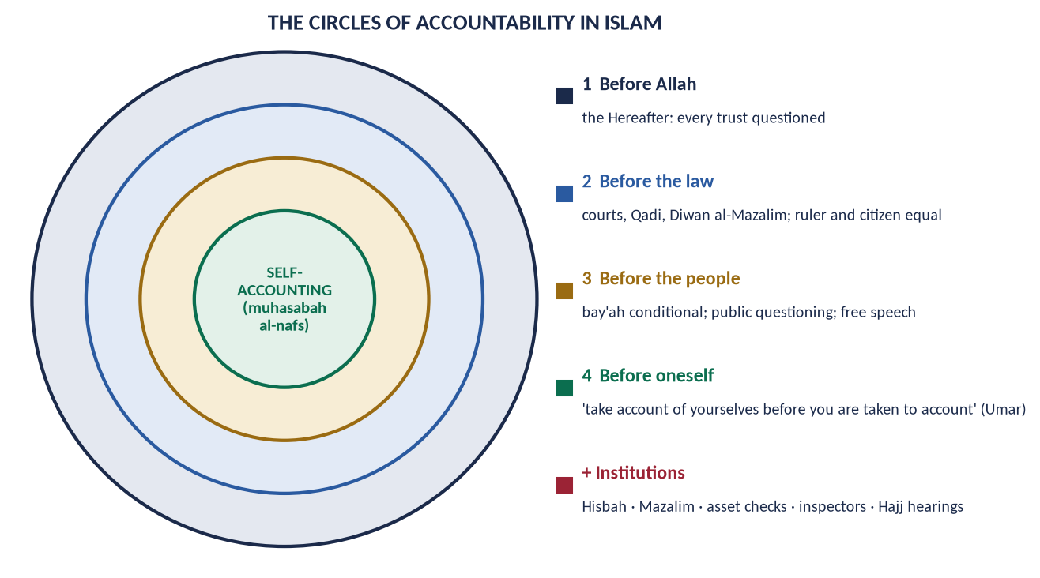
Figure 20 · The circles of accountability in Islam.

(2) The principles of accountability of rulers

Principle 1 — Power is a trust
✦ QURAN
﴿إِنَّ ٱللَّهَ يَأۡمُرُكُمۡ أَن تُؤَدُّواْ ٱلۡأَمَٰنَٰتِ إِلَىٰٓ أَهۡلِهَا وَإِذَا حَكَمۡتُم بَيۡنَ ٱلنَّاسِ أَن تَحۡكُمُواْ بِٱلۡعَدۡلِۚ …﴾
“Indeed, Allah commands you to render trusts to those entitled to them, and when you judge between people, to judge with justice.” (An-Nisa, Quran)
➜ Allah commands you to render trusts to those entitled to them, and to judge with justice.

✦ HADITH
وَإِنَّهَا أَمَانَةٌ، وَإِنَّهَا يَوْمَ الْقِيَامَةِ خِزْيٌ وَنَدَامَةٌ، إِلَّا مَنْ أَخَذَهَا بِحَقِّهَا وَأَدَّى الَّذِي عَلَيْهِ فِيهَا
“It (office) is a trust, and on the Day of Resurrection it is disgrace and regret, except for one who takes it by right and fulfils its duty.” (Muslim)

A trust is returned with an account.

Principle 2 — Every ruler will be questioned
✦ HADITH
الْإِمَامُ رَاعٍ وَمَسْئُولٌ عَنْ رَعِيَّتِهِ
“The ruler is a shepherd and is responsible for his flock.” (Al-Bukhari and Muslim)

✦ HADITH
مَا مِنْ عَبْدٍ يَسْتَرْعِيهِ اللَّهُ رَعِيَّةً، يَمُوتُ يَوْمَ يَمُوتُ وَهُوَ غَاشٌّ لِرَعِيَّتِهِ، إِلَّا حَرَّمَ اللَّهُ عَلَيْهِ الْجَنَّةَ
“No servant whom Allah places over people, and who dies deceiving them, but Allah forbids Paradise for him.” (Muslim)

Principle 3 — The ruler is under the law
✦ QURAN
﴿… وَمَن لَّمۡ يَحۡكُم بِمَآ أَنزَلَ ٱللَّهُ فَأُوْلَـٰٓئِكَ هُمُ ٱلۡكَٰفِرُونَ﴾
“And whoever does not judge by what Allah has revealed — it is they who are the disbelievers.” (Al-Ma'idah, Quran)
➜ Whoever does not judge by what Allah has revealed — those are the disbelievers.

✦ HADITH
وَايْمُ اللَّهِ لَوْ أَنَّ فَاطِمَةَ بِنْتَ مُحَمَّدٍ سَرَقَتْ لَقَطَعْتُ يَدَهَا
“By Allah, if Fatimah the daughter of Muhammad stole, I would cut off her hand.” (Al-Bukhari and Muslim)

The Prophet ﷺ himself offered retaliation to Sawad ibn Ghaziyyah at Badr (Ibn Ishaq). The ruler has no immunity.

Principle 4 — Obedience is conditional
✦ QURAN
﴿يَـٰٓأَيُّهَا ٱلَّذِينَ ءَامَنُوٓاْ أَطِيعُواْ ٱللَّهَ وَأَطِيعُواْ ٱلرَّسُولَ وَأُوْلِي ٱلۡأَمۡرِ مِنكُمۡۖ فَإِن تَنَٰزَعۡتُمۡ فِي شَيۡءٖ فَرُدُّوهُ إِلَى ٱللَّهِ وَٱلرَّسُولِ إِن كُنتُمۡ تُؤۡمِنُونَ بِٱللَّهِ وَٱلۡيَوۡمِ ٱلۡأٓخِرِۚ ذَٰلِكَ خَيۡرٞ وَأَحۡسَنُ تَأۡوِيلًا﴾
“Obey Allah and obey the Messenger and those in authority among you. If you disagree over anything, refer it to Allah and the Messenger …” (An-Nisa, Quran)
➜ Obedience to rulers comes after obedience to Allah and His Messenger, and disputes go to the higher law.

✦ HADITH
لَا طَاعَةَ فِي مَعْصِيَةٍ، إِنَّمَا الطَّاعَةُ فِي الْمَعْرُوفِ
“There is no obedience in disobedience; obedience is only in what is right.” (Al-Bukhari and Muslim)

Principle 5 — The people have the right to question and correct
✦ FROM THE SIRAH
فَإِنْ أَحْسَنْتُ فَأَعِينُونِي، وَإِنْ أَسَأْتُ فَقَوِّمُونِي
“If I do well, help me; if I do wrong, set me right.” (Ibn Hisham)
➜ Abu Bakr's (RA) first address.

✦ HADITH
أَفْضَلُ الْجِهَادِ كَلِمَةُ عَدْلٍ عِنْدَ سُلْطَانٍ جَائِرٍ
“The best jihad is a word of justice before a tyrant ruler.” (Abu Dawud and Al-Tirmidhi)

✦ HADITH
الدِّينُ النَّصِيحَةُ ... وَلِأَئِمَّةِ الْمُسْلِمِينَ وَعَامَّتِهِمْ
“Religion is sincere advice … to the leaders of the Muslims and their common people.” (Muslim)

Principle 6 — Transparency of wealth
✦ QURAN
﴿وَمَا كَانَ لِنَبِيٍّ أَن يَغُلَّۚ وَمَن يَغۡلُلۡ يَأۡتِ بِمَا غَلَّ يَوۡمَ ٱلۡقِيَٰمَةِۚ ثُمَّ تُوَفَّىٰ كُلُّ نَفۡسٖ مَّا كَسَبَتۡ وَهُمۡ لَا يُظۡلَمُونَ﴾
“It is not [attributable] to any prophet that he would act unfaithfully [in regard to war booty]. And whoever betrays, [taking unlawfully], will come with what he took on the Day of Resurrection. Then will every soul be [fully] compensated for what it earned, and they will not be wronged.” (Aal-e-Imran, Quran)
➜ Whoever betrays will bring what he took on the Day of Resurrection.

✦ HADITH
وَعَنْ مَالِهِ مِنْ أَيْنَ اكْتَسَبَهُ وَفِيمَ أَنْفَقَهُ
“… and about his wealth: where he earned it and how he spent it.” (Al-Tirmidhi)

Umar (RA) kept a register of his governors' wealth and shared unexplained gains with the treasury.

Principle 7 — No private gain from office
✦ HADITH
فَهَلَّا جَلَسَ فِي بَيْتِ أَبِيهِ أَوْ بَيْتِ أُمِّهِ فَيَنْظُرَ يُهْدَى لَهُ أَمْ لَا
“Why did he not sit in the house of his father or mother and see whether gifts would come to him?” (Al-Bukhari)
➜ The case of Ibn al-Lutbiyyah.

No office for relatives on that ground alone: 'when authority is given to those not fit for it, wait for the Hour' (Al-Bukhari).

Principle 8 — Consultation checks the ruler
✦ QURAN
﴿فَبِمَا رَحۡمَةٖ مِّنَ ٱللَّهِ لِنتَ لَهُمۡۖ وَلَوۡ كُنتَ فَظًّا غَلِيظَ ٱلۡقَلۡبِ لَٱنفَضُّواْ مِنۡ حَوۡلِكَۖ …﴾
“So by mercy from Allah you were gentle with them; had you been harsh and hard-hearted, they would have scattered from around you.” (Aal-e-Imran, Quran)
➜ 'Consult them in the matter, and when you have decided, rely upon Allah.'

✦ QURAN
﴿وَٱلَّذِينَ ٱسۡتَجَابُواْ لِرَبِّهِمۡ وَأَقَامُواْ ٱلصَّلَوٰةَ وَأَمۡرُهُمۡ شُورَىٰ بَيۡنَهُمۡ وَمِمَّا رَزَقۡنَٰهُمۡ يُنفِقُونَ﴾
“And those who have responded to their lord and established prayer and whose affair is [determined by] consultation among themselves, and from what We have provided them, they spend.” (Ash-Shura, Quran)
➜ Their affairs are by consultation among themselves.

A ruler who must consult cannot act alone.

Principle 9 — Independent judges
✦ QURAN
﴿يَـٰٓأَيُّهَا ٱلَّذِينَ ءَامَنُواْ كُونُواْ قَوَّـٰمِينَ بِٱلۡقِسۡطِ شُهَدَآءَ لِلَّهِ وَلَوۡ عَلَىٰٓ أَنفُسِكُمۡ أَوِ ٱلۡوَٰلِدَيۡنِ وَٱلۡأَقۡرَبِينَۚ …﴾
“O you who believe, stand firmly for justice, as witnesses for Allah, even if it be against yourselves, your parents or your relatives.” (An-Nisa, Quran)
➜ Stand firm for justice … even against yourselves.

The Prophet ﷺ taught Ali: 'Do not judge for the first until you hear the other' (Al-Tirmidhi). Umar stood in court before Zayd ibn Thabit; Ali lost his case before Qadi Shurayh.

Principle 10 — Removal of the unjust by lawful means
Rulers who betray the trust may be removed through lawful, peaceful means (the Shura, the people's bay'ah, today the Constitution). Armed revolt that causes greater fitnah is not permitted. Umar removed governors on complaint, even Sa'd ibn Abi Waqqas, to keep public trust.

(3) The principles in practice — the Rashidun
Caliph | Accountability in action
Abu Bakr (RA) | 'Set me right'; stipend fixed by the Companions and returned at his death
Umar (RA) | Asset register; inspector Muhammad ibn Maslamah; complaints heard at Hajj; his sons' profit shared with the treasury (Al-Muwatta')
Uthman (RA) | Answered his critics publicly in the Mosque; sent inspectors to the provinces
Ali (RA) | Lost his own case before Shurayh; refused his brother extra from the treasury

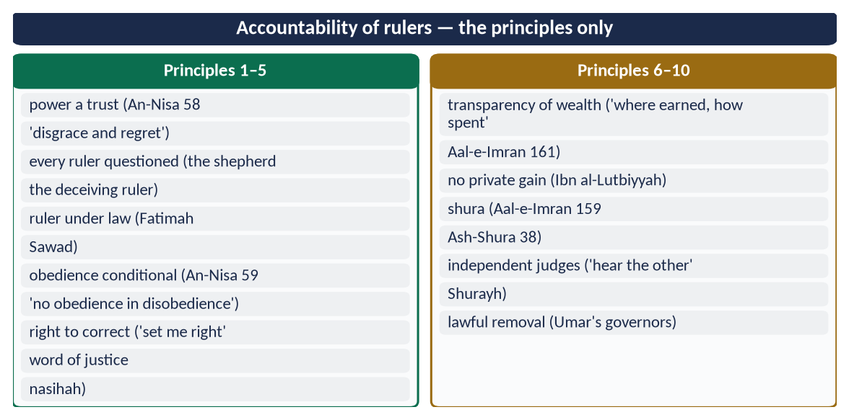
Figure 21 · At a glance — accountability of rulers — the principles only. The detail is in the sections above.

(4) Conclusion
✦ HADITH
إِنَّ الْمُقْسِطِينَ عِنْدَ اللَّهِ عَلَى مَنَابِرَ مِنْ نُورٍ ... الَّذِينَ يَعْدِلُونَ فِي حُكْمِهِمْ وَأَهْلِيهِمْ وَمَا وَلُوا
“The just will be with Allah on pulpits of light … those who are just in their rule, with their families and in whatever they are put in charge of.” (Muslim)

The Quran and Sunnah make the ruler a trustee: questioned by Allah, bound by law, corrected by the people, checked by consultation and judged by independent courts. These ten principles, lived by the Rashidun, are the foundation of good governance in any age.

Why this answer scores
- Ten clearly worded principles, as 'express the principles' requires.
- Quran first, then Sunnah for every principle; the Rashidun only illustrate.
- A practice table shows the principles lived, and the conclusion ends with a Prophetic promise.

Answer 8 · Idealising Pakistan's Accountability System in the Teachings of the Holy Prophet ﷺ (CSS 2024)
THE QUESTION · CSS 2024 · Q6 · 20 marks
How can the system of accountability in Pakistan be idealized in the teachings of the Holy Prophet (ﷺ)? Explain.

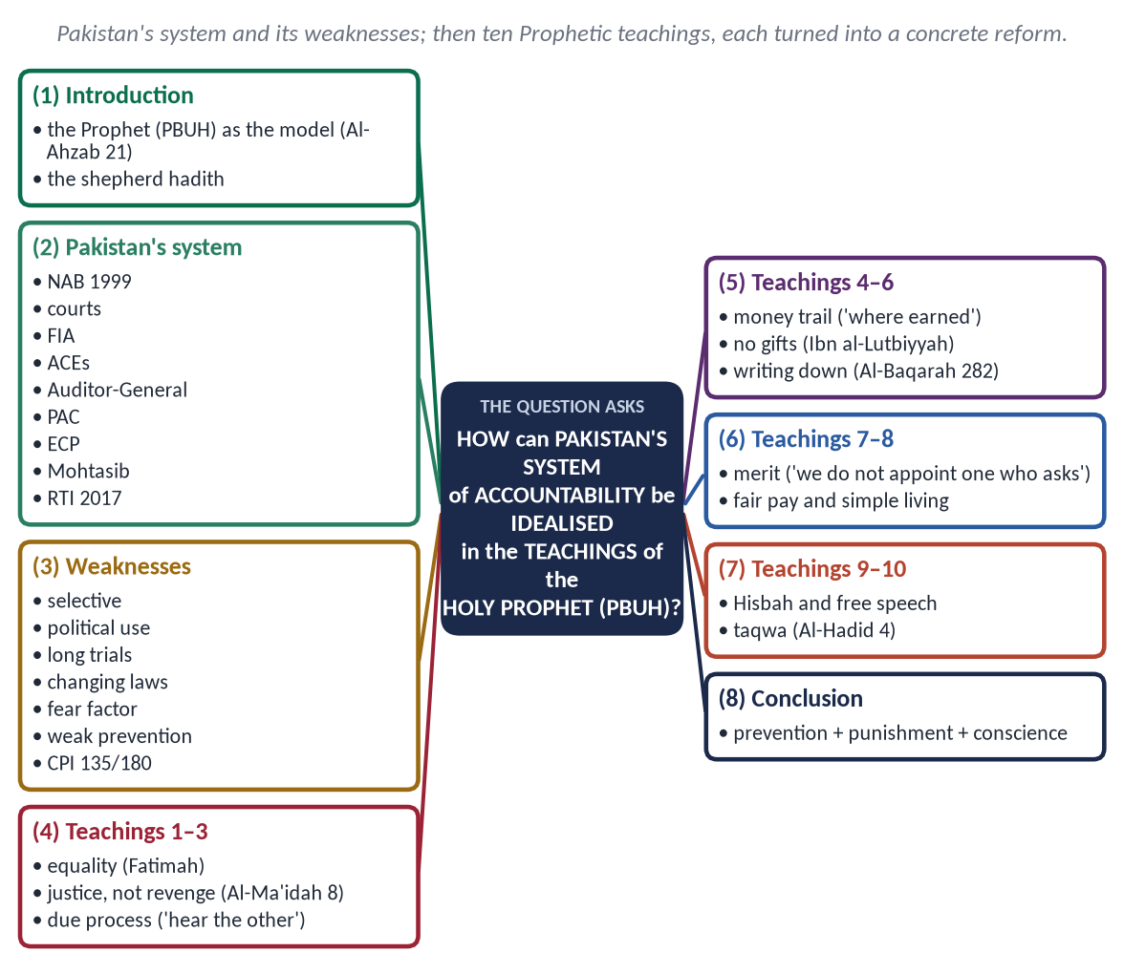
Figure 22 · The answer map: every branch is one numbered heading of the model answer below.

Decoding the question
- 'System of accountability in Pakistan' — describe the existing institutions and their weaknesses.
- 'Idealized in the teachings of the Holy Prophet ﷺ' — the Prophet's ﷺ teachings are the ideal. For each teaching, show what Pakistan should change.
- 'How can … Explain' — practical steps, not only principles.

The model answer

(1) Introduction
✦ QURAN
﴿لَّقَدۡ كَانَ لَكُمۡ فِي رَسُولِ ٱللَّهِ أُسۡوَةٌ حَسَنَةٞ لِّمَن كَانَ يَرۡجُواْ ٱللَّهَ وَٱلۡيَوۡمَ ٱلۡأٓخِرَ وَذَكَرَ ٱللَّهَ كَثِيرٗا﴾
“There has certainly been for you in the Messenger of Allah an excellent pattern for anyone whose hope is in Allah and the Last Day and [who] remembers Allah often.” (Al-Ahzab, Quran)
➜ 'There has certainly been for you in the Messenger of Allah an excellent example.'

The Prophet ﷺ built a state where the ruler's own family was under the law, officials were checked on their return, and the humblest citizen could demand justice. Pakistan has many accountability laws but little public trust. His teachings show how to turn the system into an ideal one.

(2) Pakistan's system of accountability
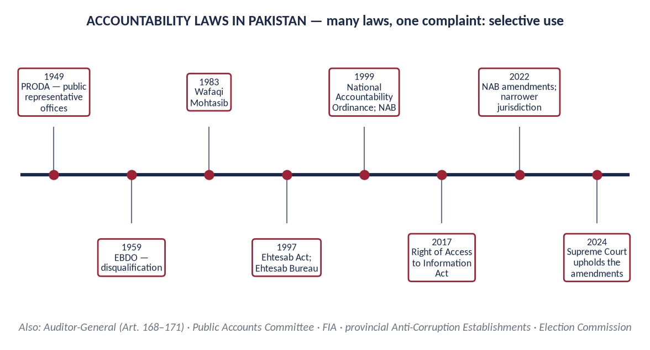
Figure 23 · Accountability laws in Pakistan since 1949.
- NAB — under the National Accountability Ordinance (1999), with accountability courts.
- FIA and provincial Anti-Corruption Establishments.
- The Auditor-General (Articles 168–171) and Parliament's Public Accounts Committee.
- The Election Commission — members' asset declarations.
- The Wafaqi and provincial Mohtasibs — maladministration.
- The Right of Access to Information Act (2017).
- The superior courts — judicial review.

(3) Its weaknesses
- Selective accountability — seen as aimed at opponents, sparing allies.
- Political use — from PRODA (1949) and EBDO (1959) to recent times.
- Long trials and low convictions.
- Changing laws — the 2022 amendments narrowed NAB's reach, were partly struck down in 2023, and were upheld in 2024.
- The fear factor — honest officers avoid decisions.
- Weak prevention — punishment after the fact instead of transparency before it.
- Low trust — Transparency International's CPI 2024 placed Pakistan 135th of 180.

(4) Idealising the system in the teachings of the Holy Prophet ﷺ

(i) Equality — accountability for all
✦ HADITH
إِنَّمَا أَهْلَكَ الَّذِينَ قَبْلَكُمْ أَنَّهُمْ كَانُوا إِذَا سَرَقَ فِيهِمُ الشَّرِيفُ تَرَكُوهُ، وَإِذَا سَرَقَ فِيهِمُ الضَّعِيفُ أَقَامُوا عَلَيْهِ الْحَدَّ
“Those before you were destroyed because when a noble person stole they let him go, and when a weak person stole they punished him.” (Al-Bukhari and Muslim)

Reform: one law for politicians, officials, judges, officers and businessmen. An accountability body independent of the government of the day, headed by a person chosen by consensus of government and opposition.

(ii) Justice, not revenge
✦ QURAN
﴿… وَلَا يَجۡرِمَنَّكُمۡ شَنَـَٔانُ قَوۡمٍ عَلَىٰٓ أَلَّا تَعۡدِلُواْۚ ٱعۡدِلُواْ هُوَ أَقۡرَبُ لِلتَّقۡوَىٰۖ …﴾
“Do not let the hatred of a people lead you to be unjust. Be just; that is nearer to righteousness.” (Al-Ma'idah, Quran)
➜ Do not let the hatred of a people lead you to injustice. Be just.

Reform: no case opened for political reasons; neutral prosecutors; penalties for false cases.

(iii) Due process — hear both sides
✦ HADITH
فَلَا تَقْضِ لِلْأَوَّلِ حَتَّى تَسْمَعَ كَلَامَ الْآخَرِ
“Do not judge for the first until you hear the other.” (Al-Tirmidhi)

'The burden of proof is on the claimant' (Umar's letter). Reform: the right to a fair trial (Article 10-A); no arrest without evidence; no media trials; time-bound trials in special courts.

(iv) The money trail
✦ HADITH
وَعَنْ مَالِهِ مِنْ أَيْنَ اكْتَسَبَهُ وَفِيمَ أَنْفَقَهُ
“… and about his wealth: where he earned it and how he spent it.” (Al-Tirmidhi)

Reform: yearly, public and verified asset declarations by all office-holders, as Umar kept a register of his governors' wealth. Unexplained wealth must be explained.

(v) No gifts of office
The Prophet ﷺ rebuked Ibn al-Lutbiyyah: 'Why did he not sit in his father's house and see whether gifts would come to him?' (Al-Bukhari). Reform: official gifts belong to the state, with public records; strict rules against conflict of interest.

(vi) Prevention through record and transparency
✦ QURAN
﴿يَـٰٓأَيُّهَا ٱلَّذِينَ ءَامَنُوٓاْ إِذَا تَدَايَنتُم بِدَيۡنٍ إِلَىٰٓ أَجَلٖ مُّسَمّٗى فَٱكۡتُبُوهُۚ …﴾
“O you who believe, when you contract a debt for a fixed term, write it down.” (Al-Baqarah, Quran)
➜ O you who believe, when you contract a debt for a fixed term, write it down.

The Prophet ﷺ had records kept and checked his collectors on their return. Reform: e-procurement, digital payments, open budgets, and the Right to Information Act enforced. Transparency removes the chance to steal.

(vii) Merit in appointments
✦ HADITH
إِنَّا وَاللَّهِ لَا نُوَلِّي عَلَى هَذَا الْعَمَلِ أَحَدًا سَأَلَهُ، وَلَا أَحَدًا حَرَصَ عَلَيْهِ
“By Allah, we do not appoint to this work anyone who asks for it or is eager for it.” (Al-Bukhari and Muslim)

Reform: appointments through Public Service Commissions; an end to sifarish and political postings in police, revenue and accountability bodies.

(viii) Fair pay, simple living
The Companions fixed a modest stipend for Abu Bakr, sufficient for his needs. Ali told his governor to pay officials enough that they would not be tempted. Reform: a living wage for officials, and an end to luxury perks and protocol for the powerful.

(ix) Hisbah — the voice of the people
✦ HADITH
مَنْ رَأَى مِنْكُمْ مُنْكَرًا فَلْيُغَيِّرْهُ بِيَدِهِ، فَإِنْ لَمْ يَسْتَطِعْ فَبِلِسَانِهِ
“Whoever sees a wrong, let him change it with his hand; if he cannot, then with his tongue.” (Muslim)

Reform: strong Mohtasib offices, whistle-blower protection, a free and responsible press, and the Citizen's Portal — the modern tongue of Hisbah.

(x) Taqwa — the inner auditor
✦ QURAN
﴿… وَهُوَ مَعَكُمۡ أَيۡنَ مَا كُنتُمۡۚ وَٱللَّهُ بِمَا تَعۡمَلُونَ بَصِيرٞ﴾
“And He is with you wherever you are; and Allah sees what you do.” (Al-Hadid, Quran)
➜ 'He is with you wherever you are, and Allah sees what you do.'

Reform: ethics and character training for officials; oaths of office taken seriously. No law can stop a thief who does not fear Allah.

(5) The ideal at a glance
Prophetic teaching | Reform in Pakistan
Equality (Fatimah) | One law for all; independent NAB
Justice, not revenge | Consensus chief; penalties for false cases
Hear both sides | Article 10-A; time-bound trials
Where earned, how spent | Public, verified asset declarations
No gifts (Ibn al-Lutbiyyah) | State gifts recorded; conflict-of-interest rules
Write it down | E-governance; RTI; open budgets
Merit | Public Service Commissions; no sifarish
Fair pay, simple living | Living wage; no luxury perks
Hisbah | Mohtasib; whistle-blowers; free press
Taqwa | Ethics training; character education

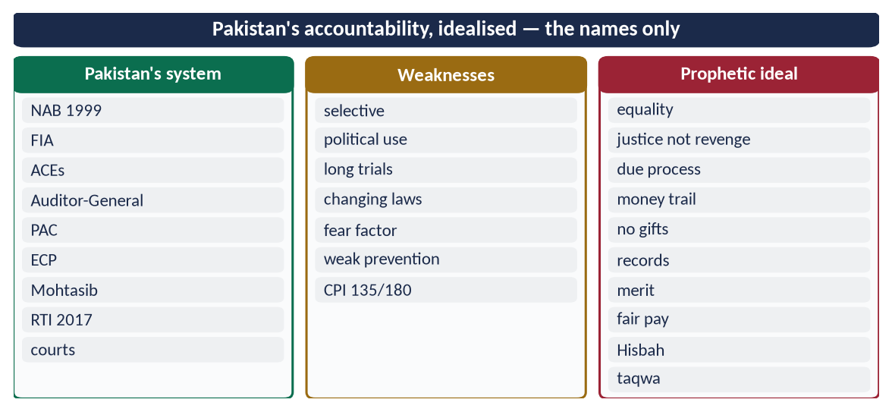
Figure 24 · At a glance — pakistan's accountability, idealised — the names only. The detail is in the sections above.

(6) Conclusion
✦ HADITH
كُلُّكُمْ رَاعٍ وَكُلُّكُمْ مَسْئُولٌ عَنْ رَعِيَّتِهِ
“Each of you is a shepherd and each is responsible for his flock.” (Al-Bukhari and Muslim)

Pakistan's accountability system can become ideal if it follows the Prophet ﷺ in three ways:
- punishment that is equal and fair;
- prevention through transparency and merit;
- conscience through taqwa.
Then accountability will be feared by the corrupt and trusted by the people.

Why this answer scores
- It describes the system and its weaknesses before idealising it, so the 'how' has a starting point.
- Ten Prophetic teachings, each turned into a specific reform, with a summary table.
- Neutral on parties; firm on principles.

Answer 9 · The Concept of Accountability and the Highest Standard of the Rashidun Caliphs (CSS 2026)
THE QUESTION · CSS 2026 · Q6 · 20 marks
Explain the concept of accountability in the Islamic system. Demonstrate with examples that the practices of the Rashidun Caliphs in this perspective set the highest standard.

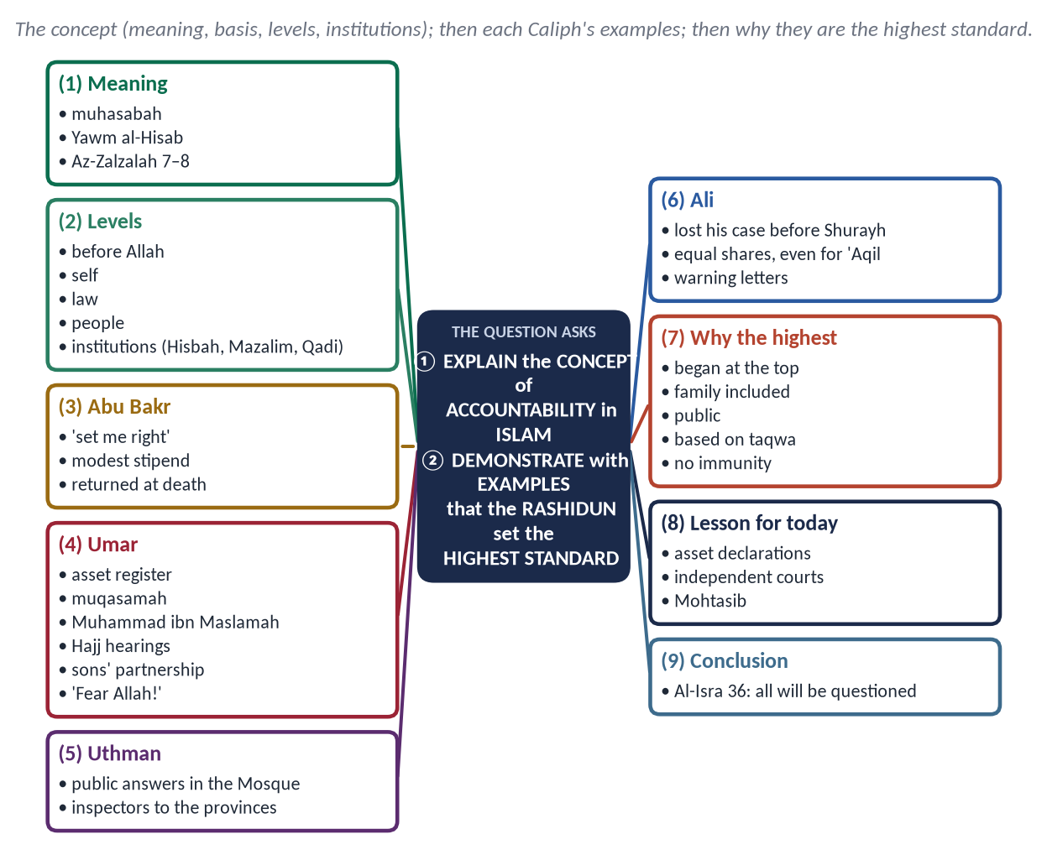
Figure 25 · The answer map: every branch is one numbered heading of the model answer below.

Decoding the question
- 'Explain the concept' — the meaning, basis and levels of accountability in the Islamic system.
- 'Demonstrate with examples' — named, concrete examples from each of the four Caliphs.
- 'Set the highest standard' — argue why these examples are unmatched.

The model answer

(1) The concept of accountability in the Islamic system

(i) Meaning
Accountability (muhasabah, مُحَاسَبَة) means answering for every use of power, wealth and trust. In Islam it rests on belief in the Day of Reckoning (Yawm al-Hisab).
✦ QURAN
﴿فَمَن يَعۡمَلۡ مِثۡقَالَ ذَرَّةٍ خَيۡرٗا يَرَهُۥ ۝ وَمَن يَعۡمَلۡ مِثۡقَالَ ذَرَّةٖ شَرّٗا يَرَهُۥ﴾
“So whoever does an atom's weight of good will see it. And whoever does an atom's weight of evil will see it.” (Az-Zalzalah, Quran)
➜ Whoever does an atom's weight of good will see it, and whoever does an atom's weight of evil will see it.

✦ QURAN
﴿وَلَا تَقۡفُ مَا لَيۡسَ لَكَ بِهِۦ عِلۡمٌۚ إِنَّ ٱلسَّمۡعَ وَٱلۡبَصَرَ وَٱلۡفُؤَادَ كُلُّ أُوْلَـٰٓئِكَ كَانَ عَنۡهُ مَسۡـُٔولٗا﴾
“And do not pursue that of which you have no knowledge. Indeed, the hearing, the sight and the heart - about all those [one] will be questioned.” (Al-Isra, Quran)
➜ The hearing, the sight and the heart — all of these will be questioned.

(ii) The basis — power as a trust
✦ QURAN
﴿إِنَّ ٱللَّهَ يَأۡمُرُكُمۡ أَن تُؤَدُّواْ ٱلۡأَمَٰنَٰتِ إِلَىٰٓ أَهۡلِهَا وَإِذَا حَكَمۡتُم بَيۡنَ ٱلنَّاسِ أَن تَحۡكُمُواْ بِٱلۡعَدۡلِۚ …﴾
“Indeed, Allah commands you to render trusts to those entitled to them, and when you judge between people, to judge with justice.” (An-Nisa, Quran)
➜ Allah commands you to render trusts to those entitled to them, and to judge with justice.

✦ HADITH
كُلُّكُمْ رَاعٍ وَكُلُّكُمْ مَسْئُولٌ عَنْ رَعِيَّتِهِ
“Each of you is a shepherd and each is responsible for his flock.” (Al-Bukhari and Muslim)

(iii) The levels of accountability
Figure 26 · The circles of accountability in Islam.
- Before Allah:
✦ HADITH
لَا تَزُولُ قَدَمَا عَبْدٍ يَوْمَ الْقِيَامَةِ حَتَّى يُسْأَلَ ... وَعَنْ مَالِهِ مِنْ أَيْنَ اكْتَسَبَهُ وَفِيمَ أَنْفَقَهُ
“The feet of a servant will not move on the Day of Resurrection until he is asked … about his wealth, where he earned it and how he spent it.” (Al-Tirmidhi)

- Before oneself: 'Take account of yourselves before you are taken to account' (Umar).
- Before the law: 'If Fatimah stole, I would cut off her hand' (Al-Bukhari and Muslim).
- Before the people: 'The best jihad is a word of justice before a tyrant ruler' (Abu Dawud).
- Through institutions:
- the Qadi (judge);
- Hisbah — 'whoever cheats is not of me' (Muslim), the market inspection;
- Mazalim — the court of complaints against officials.

(2) The Rashidun Caliphs — examples of the highest standard

(i) Hazrat Abu Bakr (RA), 632–634
- Accountability announced on the first day: 'If I do well, help me; if I do wrong, set me right … obey me as long as I obey Allah' (Ibn Hisham).
- The stipend. After becoming Caliph he went to the market to trade. The Companions fixed a modest stipend so that he could serve full time; Aishah (RA) reported his words: 'The family of Abu Bakr will eat from this wealth, and he will work for the Muslims' (Al-Bukhari).
- The return. Before his death he ordered that what he had received be returned to the treasury from his own property. Umar wept and said: 'He has made it hard for those who come after him.'

(ii) Hazrat Umar (RA), 634–644
- Asset register: the wealth of every governor was listed at appointment. Unexplained increases were shared with the treasury (muqasamah), as with Abu Hurayrah in Bahrain and Amr ibn al-As in Egypt.
- Inspector-general: Muhammad ibn Maslamah (RA) investigated complaints against governors.
- Annual public hearing: governors came to Hajj, where any citizen could complain against them.
- Removal to protect trust: he removed Sa'd ibn Abi Waqqas from Kufa after complaints, although an inquiry cleared him.
- His own family first: his sons Abdullah and Ubaydullah had traded with a treasury loan given by Abu Musa. Umar made it a partnership, with half the profit to the treasury (Al-Muwatta', Book of Qirad).
- Open to criticism: told 'Fear Allah!' in public, he said, 'There is no good in you if you do not say it, and no good in us if we do not hear it.'
- The governor's son and the Copt: 'Since when have you enslaved people whose mothers bore them free?'

(iii) Hazrat Uthman (RA), 644–656
- When charges were raised against his administration, he answered them publicly in the Mosque of Madinah.
- In 35 AH he sent inspectors to Kufa, Basra, Egypt and Syria to inquire into the governors.
- He refused to let blood be shed to protect himself.

(iv) Hazrat Ali (RA), 656–661
- The Caliph lost in court: he sued a man over his armour before Qadi Shurayh, could not produce acceptable witnesses, and accepted the judgement against himself.
- No favour to family: he refused his own brother 'Aqil more than his share from the treasury.
- Warnings to governors: even if his own sons Hasan and Husayn had misused public money, they would have found no favour with him.
- Instructions: in his letter to Malik al-Ashtar, appoint officials by test and keep watch on them through trustworthy inspectors.

(3) Why the Rashidun set the highest standard
Mark of the standard | Example
It began at the top | The Caliph accounted first: Abu Bakr's stipend; Ali in court
Family was not spared | Umar's sons; Ali's brother 'Aqil
It was public | Hajj hearings; Uthman's answers in the Mosque; 'Fear Allah!' accepted
It was preventive | Asset registers; written conditions for governors (no doorkeeper, no luxury)
It was just | Inquiries before judgement (Muhammad ibn Maslamah); Sa'd cleared, yet removed for trust
It rested on taqwa | Rulers who feared Allah more than the people
No immunity | The ruler stood before the judge like any citizen

No modern system has achieved all these together. Modern states have laws; the Rashidun had laws and character.

(4) The lesson for today
For Pakistan the lesson is clear:
- asset declarations that are public and verified, as in Umar's register;
- independent courts before which the powerful stand like others, as Ali did;
- Mohtasib offices that hear the citizen, as Umar did at Hajj;
- leaders who begin with themselves and their families.
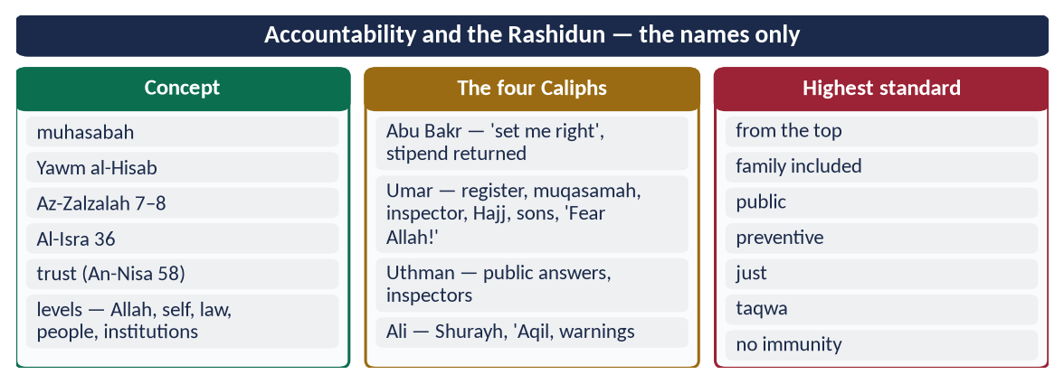
Figure 27 · At a glance — accountability and the Rashidun — the names only. The detail is in the sections above.

(5) Conclusion
✦ QURAN
﴿وَنَضَعُ ٱلۡمَوَٰزِينَ ٱلۡقِسۡطَ لِيَوۡمِ ٱلۡقِيَٰمَةِ فَلَا تُظۡلَمُ نَفۡسٞ شَيۡـٔٗاۖ وَإِن كَانَ مِثۡقَالَ حَبَّةٖ مِّنۡ خَرۡدَلٍ أَتَيۡنَا بِهَاۗ وَكَفَىٰ بِنَا حَٰسِبِينَ﴾
“And We place the scales of justice for the Day of Resurrection, so no soul will be treated unjustly at all. And if there is [even] the weight of a mustard seed, We will bring it forth. And sufficient are We as accountant.” (Al-Anbiya, Quran)
➜ We shall set up the scales of justice for the Day of Resurrection, so no soul will be wronged at all.

In Islam accountability is a belief before it is a law. The Rashidun Caliphs turned that belief into practice. They accounted for themselves first, then their families, then their governors, in public and without fear. That is why their practice remains the highest standard of accountability in human history.

Why this answer scores
- The concept is explained fully: meaning, basis, levels and institutions.
- Named examples from all four Caliphs, as 'demonstrate with examples' requires.
- A table proves why the standard is the highest, and the lesson is applied to Pakistan.

